**Design of Compact Rectenna for UAV Applications**

**A Project Report**

Submitted by:

**Siddharth Yadav (2114098)**

**Uttirna Talukdar (2114144)**

**Niyar R Barman (2114145)**

**In partial fulfilment for the award of the degree**

**of**

**BACHELOR OF TECHNOLOGY**

**IN**

**ELECTRONICS AND COMMUNICATION ENGINEERING**



**DEPARTMENT OF ELECTRONICS AND COMMUNICATION ENGINEERING**

**NATIONAL INSTITUTE OF TECHNOLOGY SILCHAR,**

**SILCHAR, ASSAM (INDIA)-788010**

**MAY 2025**

# DECLARATION

I hereby declare that the project entitled “**Design of Compact Rectenna for UAV Applications**” submitted for the B. Tech. (ECE) degree is my original work and the project has not formed the basis for the award of any other degree, diploma, fellowship or any other similar titles.

**Signature of Students**

**Siddharth Yadav Uttirna Talukdar Niyar R Barman**

**(2114098) (2114144) (2114145)**

**Place:** NIT Silchar, Assam

**Date:** 16/05/2025

# CERTIFICATE

This is to certify that the project titled “**Design and Simulation of Compact Rectenna for UAV Applications**” is the bona fide work carried out by **Siddharth Yadav (Scholar Id:2114098), Uttirna Talukdar (Scholar Id: 2114144) and Niyar R Barman (Scholar Id: 2114145)**, students of B Tech (ECE) of **National Institute of Technology Silchar** (An Institute of National Importance under MHRD, Govt. of India), Silchar, Assam, India during the academic year 2024-25, in partial fulfillment of the requirements for the award of the degree of Bachelor of Technology (Electronics and communication Engineering) and that the project has not formed the basis for the award previously of any other degree, diploma, fellowship or any other similar title.

**Dr. Taimoor Khan**

**Associate Professor**

**Electronics and Communication Engineering**

**National Institute of Technology Silchar**

**Signature of the Supervisor**

**Place:** NIT Silchar, Assam

**Date:** 16/05/2025

# ABSTRACT

This report presents the comprehensive design, simulation, and analysis of a compact rectenna system tailored for wireless power transmission (WPT) to Unmanned Aerial Vehicles (UAVs) operating at 24 GHz. The proposed rectenna integrates a microstrip patch antenna with a Schottky diode-based rectifying circuit, optimized for efficient RF-to-DC power conversion in airborne applications where weight and form factor are critical. The antenna was designed and simulated using ANSYS HFSS to evaluate electromagnetic performance parameters such as return loss, gain, and radiation pattern. The rectifier circuit was designed and analyzed in Keysight ADS, enabling accurate modeling of nonlinear diode behaviour and optimization of conversion efficiency. The antenna exhibits a broadside radiation pattern with low side lobes and effective impedance matching, ensuring maximal RF energy capture under directional transmission. The rectifying circuit achieves high conversion efficiency across a range of input power levels, demonstrating scalability and robust DC output performance. The compact design, with a footprint suitable for integration into lightweight UAV platforms, addresses the growing demand for sustainable, contactless energy delivery systems. This project contributes to the advancement of next-generation UAV power solutions, with potential applications in extended flight missions and autonomous aerial operations.

# ACKNOWLEDGEMENT

We would like to express my sincere gratitude to our supervisor, **Dr Taimoor Khan**, for their invaluable guidance, encouragement, and support throughout the course of my project. Their expertise and insights were really helpful in shaping the direction and execution of this work, and we deeply appreciate their mentorship.

We also would like to thank our teammate, for their dedication, collaboration, and hard work. Their contributions and teamwork made the completion of this project not only possible but also an enriching and fulfilling experience.

Lastly, we are grateful to our family and friends for their constant encouragement and understanding during this time.

# LIST OF FIGURES

|  |  |  |
| --- | --- | --- |
| **Figure No.** | **Name** | **Page No.** |
| 2.1 | Single Band Antenna Configurations for UAV Applications | 6 |
| 2.2 | Dual-Band Antenna Configurations for UAV Applications | 7 |
| 2.3 | Borad-band/ UWB Antenna Configurations for UAV Applications | 7 |
| 2.4 | Array Antenna Configurations for UAV Applications | 8 |
| 2.5 | Various Rectifier Designs for UAV Applications | 12 |
| 2.6 | Various Rectenna Geometry for UAV applications | 16 |
| 2.7 | Various Rectenna Array Geometry for UAV applications | 18 |
| 3.1.1 | A Simple Coaxial Probe Feed Microstrip antenna | 20 |
| 3.1.2 | 2X2 Coaxial Probe Feed Square Patch Antenna Array Geometry | 21 |
| 3.1.3 | Different Patch Structures of Equal Area | 22 |
| 3.1.6 | Slot at Centroid of Triangular Patch | 25 |
| 3.1.29 | Final Antenna Array Geometry | 39 |
| 3.2.1 | ADS Circuit Diagram for Baseline Rectifier Design based on [40] | 43 |
| 3.2.1 | ADS Circuit Diagram for Rectifier Design with Parasitic Components | 46 |
| 3.2.2 | ADS Circuit Diagram for Rectifier Design with Parasitic Components and DiClad880 Substrate | 48 |
| 3.2.3 | Annotated layout and equivalent ADS schematic of rectifier circuit | 50 |
| 3.1.4 | Complete layout of the proposed integrated rectenna | 51 |

**TABLE OF CONTENTS**

DECLARATION ii

CERTIFICATE iii

ABSTRACT iv

ACKNOWLEDGEMENT v

LIST OF FIGURES vi

1.INTRODUCTION 1

2. LITERATURE SURVEY 3

2.1 ANTENNA DESIGN FOR UAV APPLICATIONS 3

2.2 RECTIFIER DESIGN FOR UAV APPLICATION 10

2.3 RECTENNA DESIGN FOR UAV APPLICATIONS 14

3. METHODOLOGY 21

3.1 ANTENNA DESIGN 21

3.2 RECTIFIER DESIGN 43

3.3 RECTENNA DESIGN 54

4. RESULTS 55

5. CONCLUSION 56

6. REFERENCES 57

# 1.INTRODUCTION

The rapid proliferation of Unmanned Aerial Vehicles (UAVs), commonly known as drones, across diverse sectors such as surveillance, logistics, agriculture, disaster response, and infrastructure monitoring has driven the demand for innovative and efficient power solutions. Despite their transformative capabilities, the widespread adoption of drones continues to be hindered by a critical limitation — restricted flight endurance due to the limited capacity of onboard batteries. These batteries often require frequent recharging or replacement, interrupting mission continuity and increasing operational costs. As the need for longer-duration and autonomous drone operations grows, the development of alternative power delivery mechanisms has become a significant area of research.

Wireless Power Transmission (WPT) has emerged as a promising technology to address this challenge. By enabling drones to receive power remotely without physical connectors, WPT can potentially eliminate the dependency on heavy batteries and manual recharging processes. Among the various WPT techniques, radio frequency (RF)-based energy transmission stands out for its long-range capability, directional energy delivery, and ease of integration with compact hardware. A key component of this system is the rectenna — a rectifying antenna that converts incident RF energy into usable direct current (DC) power.

This project focuses on the design, simulation, and optimization of a compact rectenna system operating at 24 GHz, within the K-band frequency spectrum. The 24 GHz band offers high power transfer efficiency, reduced antenna dimensions due to its short wavelength, and suitability for compact, lightweight drone platforms. The rectenna developed in this work consists of a microstrip patch antenna integrated with a high-efficiency Schottky diode-based rectifying circuit. The microstrip design ensures a low-profile, lightweight, and easily fabricable structure, ideal for aerial platforms with stringent size and weight constraints. The Schottky diode, known for its fast switching and low forward voltage drop, enables efficient RF-to-DC conversion even at high frequencies.

To ensure optimal performance, the antenna was designed and simulated using ANSYS HFSS, focusing on critical parameters such as return loss, impedance matching, gain, and radiation pattern. The rectifier circuit was developed and analyzed using Keysight Advanced Design System (ADS), allowing accurate modeling of nonlinear diode behavior and circuit-level efficiency optimization. The primary objective of this project is to demonstrate the feasibility of a 24 GHz rectenna that meets the power requirements of small UAVs while maintaining high conversion efficiency, minimal losses, and scalability for larger systems. By addressing the challenge of limited drone endurance through WPT, this work contributes to the advancement of sustainable, contactless power solutions. Furthermore, the findings of this study lay the groundwork for future research in integrating rectennas into complete drone systems, with potential applications in remote sensing, surveillance, and continuous aerial monitoring missions.

# 2. LITERATURE SURVEY

## 2.1 ANTENNA DESIGN FOR UAV APPLICATIONS

Unmanned Aerial Vehicles (UAVs) have gained significant attention in recent years due to their wide range of applications in fields such as surveillance, remote sensing, communication, and disaster management. The design of an optimized antenna system plays a crucial role in ensuring seamless connectivity and improved performance in UAV applications. Antenna design for UAVs presents unique challenges due to the constraints of size, weight, and power consumption. The antenna must be compact, lightweight, and capable of operating at high frequencies while maintaining high efficiency and stable radiation characteristics. Additionally, UAV antennas should exhibit omnidirectional coverage, circular polarization, and sufficient gain to ensure reliable communication in dynamic environments.

Different antenna configurations [1-19] used for UAV applications are illustrated here. A novel low-profile, broad-beam conformal antenna for UAVs, featuring an L-shaped monopole with a shorted pin is discussed in [1]. It offers vertical polarization, quasi-omnidirectional radiation, and a 197° vertical beamwidth, making it ideal for UAV communication due to its simple structure and wide coverage. A 1×4 circularly polarized microstrip antenna array for UAVs, mounted on a cylindrical fuselage is investigated in [2]. Operating at 5.6 GHz with -22.24 dB return loss and 720 MHz bandwidth, it offers an omnidirectional radiation pattern. Simulation and measurements confirm the desired performance characteristics. The paper [3] presents a star-shaped dual-band microstrip patch antenna (29–30 GHz & 57–66 GHz) on a low-cost FR4 substrate. 1×2 and 1×4 arrays enhance gain (up to 4.2 dBi) and were evaluated on a UAV wing. The unit cell was fabricated and tested, with radiation patterns analyzed post-placement. A compact, low-profile omnidirectional circularly polarized (CP) antenna with four coupling arcs is proposed [4]. It combines horizontal and vertical polarizations for omnidirectional CP radiation. Shorting and inner arcs aid miniaturization. An L-band prototype (0.16λ₀ × 0.16λ₀ × 0.03λ₀) shows 13 MHz bandwidth, <2.4 dB axial ratio, and 1.01 dBic gain—suitable for UAV communications. A compact two-patch array design is proposed for unmanned aerial vehicle applications in [5]. The antenna is operated in the 2.4 GHz band. To maximize the radiation efficiency, patches with air cavities are employed. High gain directive antennas are employed to extend the wireless transmission range of either control signals or data streams. A compact dual-band 1×8 microstrip antenna array for UAV-mounted SAR applications is designed [6] at 5.8 GHz (C-band) and 9.65 GHz (X-band) using E-shaped patches on FR-4. Supporting lightweight deployment, the antenna offers >50 MHz bandwidth, 6.39 dBi gain (C-band), and 3.825 dBi (X-band), enabling dual-mode SAR data collection. An application of a simple phased antenna array intended to increase the range of a radar module is presented in [7]. The first part of this paper describes the design of a patch antenna with operating frequency of 10.5 GHz (Amateur radio X-band). The paper [8] proposes a miniaturized Annular Ring (AR) microstrip antenna for Unmanned Aerial Vehicles (UAV). A conventional annular ring antenna was opportunely scaled, and a working frequency of 2.4 GHz with a bandwidth of 160 MHz is achieved. Paper [9] presents the design of a multiple input and multiple output (MIMO) antenna for Unmanned aerial vehicle (UAV) applications working at a frequency of 2.45 GHz. The performance of two distinct designs of a 2.45GHz antenna for unmanned aerial vehicles was evaluated in this paper. The paper [10] overviews antennas used in airborne applications, highlighting sensitivity to aerial body shape and placement. Antenna position affects radiation patterns, signal strength, and cross-polarization due to azimuth, elevation angles, and polarization mixing. A system for an unmanned landing of a flying vehicle using a pseudo-conical scanning method is shown in [11]. The research work focuses on the system sensor - a linearly polarized phased antenna array with pseudo-conical scanning, for intercepting and controlling the detected object - UAV. The design feed network uses a branch-line coupler for dephasing elements. A functional model of the considered antenna system. A 2×4 compact mm-wave microstrip antenna array (21.89×10.63 mm) for UAV video streaming, operating at 52–62 GHz with -31.59 dB return loss, 14.3 dBi gain, ±15° beamwidth, and MIMO compatibility is presented in [12]. The paper [13] presents a 5G microstrip antenna (3.4–3.8 GHz) for UAVs, using a circular–semi-circular ring on RO4003 substrate. Simulated in CST, it resonates at 3.8 GHz with –39.96 dB reflection, 3.43 dBi gain, and 1.53 GHz bandwidth. Drones are gaining popularity for tasks like disaster management, sensing, and delivery. They rely on RF-based two-way communication for control and telemetry. Microstrip patch antennas, offering compactness and omnidirectional coverage, are ideal for reliable, real-time drone communication and navigation [14]. A conformal series-fed antenna for 5G UAV communication, featuring dissimilar patches and a novel inset feed is presented in [15]. Operating at 3.13 GHz with 33.8 MHz bandwidth, it ensures reliable coverage with low observability and flexible integration. The paper [16] presents a compact, low-profile ultra-wideband monopole antenna for UAVs, featuring a slotted-hexagonal patch with coplanar feed and parasitic slots for bandwidth enhancement. Covering 3–13.5 GHz with 4.0 dBi gain, the antenna offers minimal structural interference and supports seamless UAV integration with validated experimental results. A phased-array-based power beaming system utilizing a 196-element C-band antenna is developed in [17], ensuring uniform power distribution with an axial ratio <3 dB. A micro-drone successfully flew for seven minutes powered entirely by wireless energy. A novel 5.8 GHz circularly polarized antenna for RF energy harvesting is introduced in [18], designed using CST Microwave Studio, offering a 445 MHz bandwidth, reflection coefficient below -20 dB, and 6.1 dB gain. Power optimization for MAVs using a plasmonic nanoarray rectenna at 350 THz is explored in [19]. Comprising a 22-million dipole array, it produces 84.14 mW and delivers 2572 J under a 100 mW/cm² power density, potentially increasing MAV endurance by 16.3 miles.

**2.1.1 Geometrical Description of Antennas for UAV Applications**

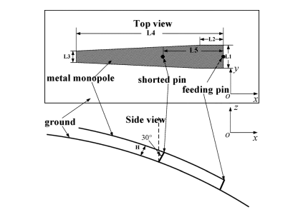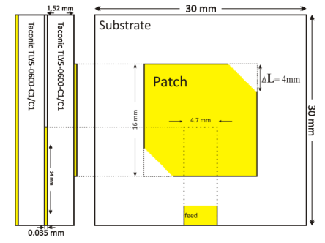

**(A) (B)**

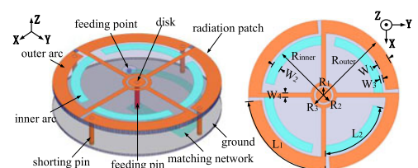 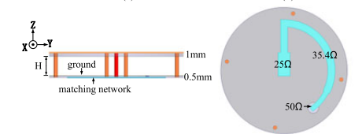

(i) (ii) (iii) (iv)

**(C)**

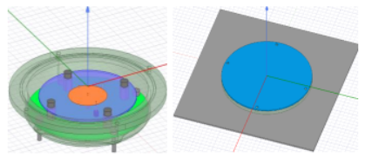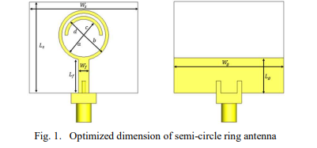

(i) (ii) (i) (ii)

**(D) (E)**

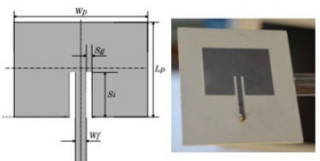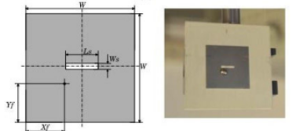

(i) (ii)

**(F)**

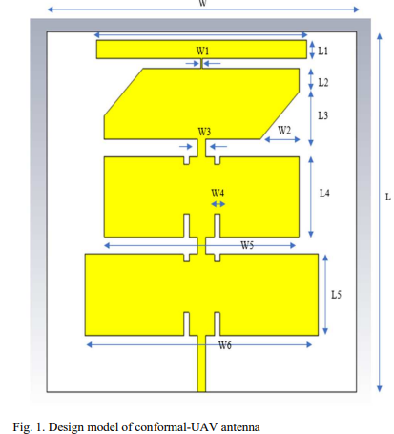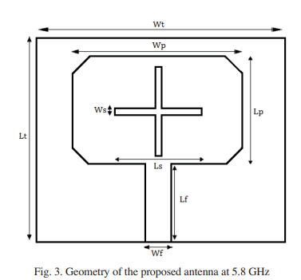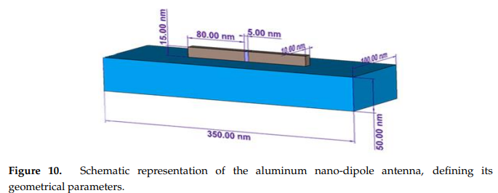

**(G) (H) (I)**

Figure 2.1: Single Band Antenna Configurations for UAV Applications; (A) Broad Beamwidth Conformal Antenna (820 MHz) for UAV [1]. (B) CP Microstrip Patch Antenna (5.6 GHz) for UAV Applications [2] (C) Low-Profile Omnidirectional CP Antenna (1.4 GHz) with four coupling arcs [4] (i) Perspective-view (ii) Top view (iii) Side-view (iv) Feeding network. (D) Annual Ring Antenna (2.4 GHz) for UAV Applications [8]: (i) Open-view of the Antenna (ii) AR Microstrip Antenna integrated into a Metallic Plate (E) Semi-circle Ring Antenna (3.8 GHz) for 5G UAV Applications [13] (i) Top-view (ii) Bottom-view (F) Microstrip Antennas [14] for UAV (2.45 GHz) (i) Linear polarized and (ii) circular polarized (G) Conformal-UAV Antenna for 5G midband (3.13 GHz) for Reliable Coverage [15].(H) Antenna Geometry (5.8 GHz) for Energy Recovery System for UAV [18] (i) Aluminium nano-dipole antenna (350 THz) for Powering Small Drone [19]

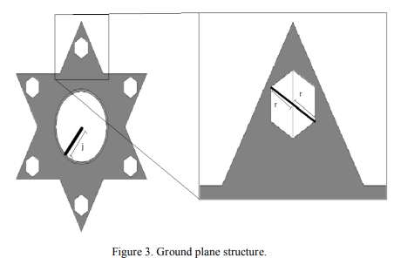 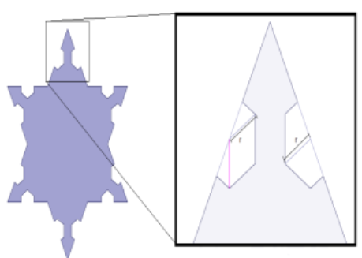

(i) (ii)

**(A)**

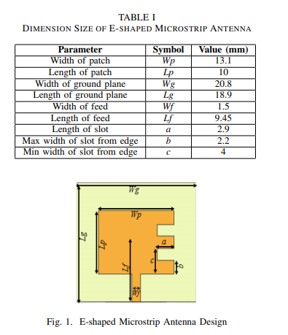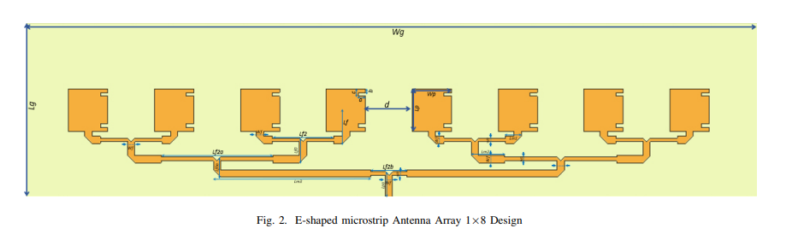

(i) (ii)

**(B)**

Figure 2.2: Dual-Band Antenna Configurations for UAV Applications; (A) Dual Band mm-wave Antenna (30 GHz, 60 GHz) for UAV [3] (i) Ground plane and (ii) Unit cell of Radiating Patch. (B) Dual C-X band E-Shaped MSA Array (5.8 GHz, 9.65 GHz) for SAR on UAV [6] (iii) Single Patch (iv) 1×8 Array

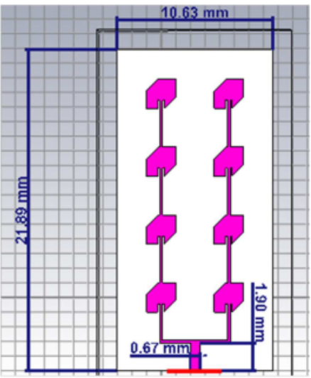 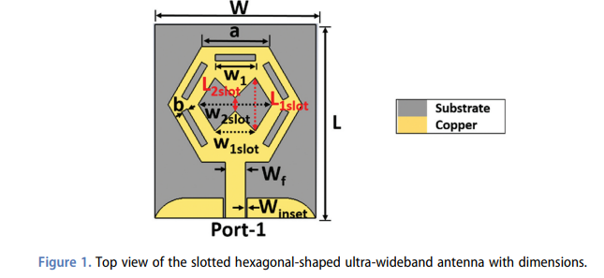

**(A) (B)**

Figure 2.3: Borad-band/ UWB Antenna Configurations for UAV Applications; (A) Antenna Array [12] for UAVs Real Time Applications using MM Waves Band (52-62 GHz) (B)Slotted Hexagonal-Shaped UWB Antenna (3-13.5 GHz) for UAV Applications [16]

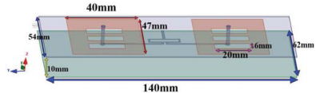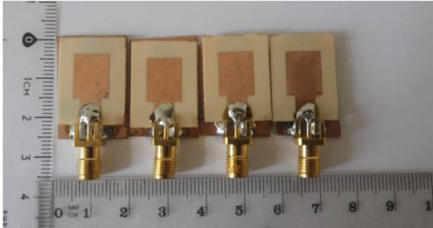

1. **(B)**

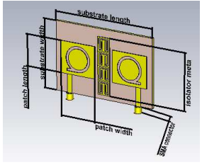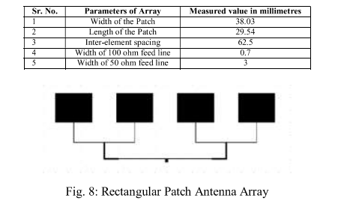 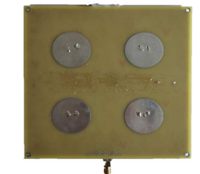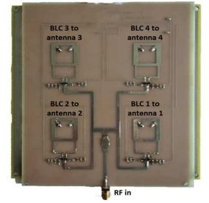

**(C) (D)** (i) (ii)

**(E)**

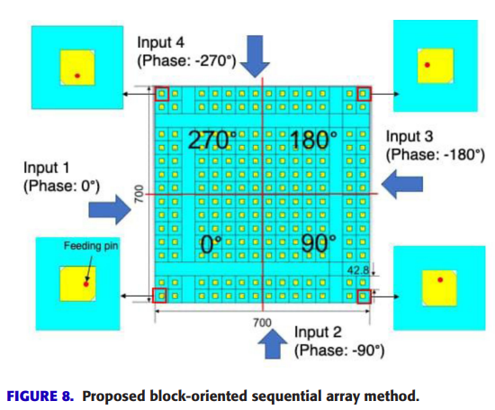

**(F)**

Figure 2.4: Array Antenna Configurations for UAV Applications; (A) Compact Two-Patch Array directive Antenna (2.4 GHz) Configuration for UAV Applications [5] (B) Fabricated Patches of Radar Antenna Array (10.5 GHz) for UAV [7] (C) Q-slotted MIMO antenna (2.45 GHz) for UAV Applications [9] (D) Rectangular Patch Antenna Array (2.58 GHz) for Airborne Applications [10] (E) Phased Antenna Array (2.4 GHz) for Automatic Landing of UAV [11] (i) Top-view and (ii) Feed Network (F) Proposed block-oriented Sequentially-Fed Array Antenna (5.74 GHz) Radiating Flat-Top Beam for Microwave Power Transmission to Drones. [17]

**2.1.2 Performance Comparison of Antenna Designs for UAV Applications**

The table compares various antenna designs for UAV applications based on geometry size, substrate type and thickness, operating frequency, bandwidth, gain, and polarization. It includes different dielectric materials like FR4, Taconic TLY5-0600, and RO4003, with thicknesses ranging from 0.1 mm to 2.65 mm. The operating frequency varies widely from 1.5 GHz to 62 GHz, with some designs offering bandwidths up to 1.53 GHz. Gain values range from 3.43 dBi to 14.3 dBi, while polarization varies between circular (CP), linear (LP), or both (LP+CP). The table highlights trade-offs in size, material, and performance, offering insights into the suitability of different designs for UAV applications.

**Table 2.1:** Performance Comparison of Existing Literature on Antennas for UAV Applications [1-19]

|  |  |  |  |  |  |  |  |  |
| --- | --- | --- | --- | --- | --- | --- | --- | --- |
| **Ref.** | **Year of Publication** | **Geometry Size** | **Substrate**  **Used** | **Substrate Thickness (mm)** | **Freq**  **(GHz)** | **Bandwidth** | **Gain**  **(dBi)** | **Polarization (CP/LP)** |
| **[1]** | 2012 | 130.8×20 mm2 | - | - | 820 MHz | 28 MHz | - | VP |
| **[2]** | 2013 | 30×30 mm2 | Taconic TLY5-0600 (2.2) | 1.52 | 5.6 GHz | 720 MHz | 5 | CP |
| **[3]** | 2016 | 69.5×9.5 mm2 | FR4 Epoxy (4.4) | 1.6 | 30 GHz,  60 GHz | 1 GHz, 9 GHz | 4.44, 5.5 | CP |
| **[4]** | 2017 | 25.3×18.5 mm2 | Not mentioned  (2.65) | Upper = 1,  Lower = 0.5 | 1.4 GHz | 13 MHz | 4.01 | CP |
| **[5]** | 2017 | 140×62 mm2 | FR4 (4.4) | 0.6 | 2.4 GHz | 140 MHz | 9.14 | LP (Vertical) |
| **[6]** | 2019 | 18.9×20.8 mm2 | FR4 (4.4) |  | 5.8 GHz,  9.65 GHz | 50 MHz | 6.39, 3.825 | - |
| **[7]** | 2020 | 11×13.1 mm2 | Rogers RO4003  (2.2) | - | 10.5 GHz |  | 12.55 | - |
| **[8]** | 2021 | Diameter = 107 mm | Isola IS680 (1),  FR4 (4.4) | 0.8 | 2.4 GHz | 160 MHz | - | - |
| **[9]** | 2021 | 40×60 mm2 | FR4(4.4) | 1.5 | 2.45 GHz | 60 | - | - |
| **[10]** | 2022 | 38.3×29.54 mm2 | - | - | 2.58 GHz | - | - | - |
| **[11]** | 2022 | - | FR4 (4.75) | 1.5 | 2.4 GHz | - | 8.5 | LP |
| **[12]** | 2023 | Array = 21.89×10.63 mm2  One Unit = 6×6 mm2 | RT/Duroid 5880  (2.2) | 0.254 | 52-62 GHz | - | 14.3 | CP |
| **[13]** | 2023 | 29.93 × 35.67 mm2 | RO4003 (3.38) | 1.5 | 3.8 GHz | 1.53 GHz | 3.43 | - |
| **[14]** | 2023 | - | RO4003G2  (6.15) | 1.524 | 2.45 GHz | - | - | LP+CP |
| **[15]** | 2024 | 79.5 × 76.12 mm2 | Polyamide9 (2.4) | 0.1 | 3.13 GHz | 33.8 MHz | - | - |
| **[16]** | 2024 | 29×24 mm2 | FR4 (4.4) | 1.57 | 3-13.5 GHz | - | 4.0 | LP |
| **[17]** | 2022 | 146×146 mm2 | NPC-F260A (2.56) | 1.6 | 5.74 GHz | - | - | CP |
| **[18]** | 2019 | 22.5×22.5 mm2 | FR4(4.4) | 1.6 | 5.8 GHz | - | 6 | - |
| **[19]** | 2019 | 350×100 nm2 | - | 50 nm | 350THz | - | - | - |

## 2.2 RECTIFIER DESIGN FOR UAV APPLICATION

Unmanned Aerial Vehicles (UAVs) are widely used in applications such as surveillance, remote sensing, and communication. As UAVs continue to evolve, energy efficiency remains a critical challenge, particularly for extending flight duration and operational capabilities. Wireless power transfer (WPT) has emerged as a viable solution, with rectifiers playing a crucial role in converting received RF energy into usable DC power. A rectifier designed for UAV applications must be highly efficient, lightweight, and capable of operating at high frequencies with minimal power losses. The key design considerations include impedance matching, low forward voltage drop, and high RF-to-DC conversion efficiency. Schottky diodes are commonly used in rectifiers due to their low barrier potential and fast switching characteristics, making them suitable for high-frequency rectification.

Different rectifier designs [20-26] used for UAV wireless power transfer applications are illustrated here. A high-power RF energy harvesting rectifier at 5.8 GHz with a conversion efficiency of 66% at 100 mW input power is discussed in [20], fabricated on a 1 mm F4B dielectric plate. A dual-band rectifier for UAVs at 2.1 GHz and 2.45 GHz using a Greinacher Voltage Doubler circuit is proposed in [21], achieving 67.263% and 51.471% conversion efficiencies, respectively, and fabricated using Proteus Design Suite. A novel rectifier with power recycling using a branch-line coupler to improve RF-DC conversion efficiency across a wide input power range is introduced in [22]. Operating at 2.45 GHz, it maintains efficiency over 50% from 8.5 to 32.5 dBm input power. Wireless magnetic resonant power transfer for UAV battery charging using a two-coil WPT system at 63.5 kHz with a 60 mm gap is analyzed in [23], optimizing coil design for efficient power transfer. The challenges and advancements in long-range microwave power transmission (MPT) for UAVs are reviewed in [24], highlighting the need for efficient transmitters, receivers, and directional radiation for remote powering. A 1 MHz single-phase Oak Ridge Converter (ORC)-based AC/DC wireless power transfer system for UAV charging is presented in [25], achieving 77% AC-DC efficiency with a 0.99 power factor at 1 kW power over a 6-inch air gap. A rectifying metasurface system (RMS) for UAV wireless power transfer, designed for wing attachment with integrated rectifying diodes, is proposed in [26]. Operating at 5.8 GHz, it achieves RF-to-DC efficiencies of 59.5% when flat and 52% when bent, demonstrating robustness against airborne vibrations and wide-angle reception capabilities.

**2.2.1 Rectifier Geometries for UAV Applications**

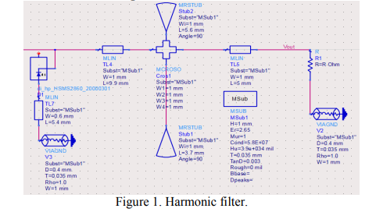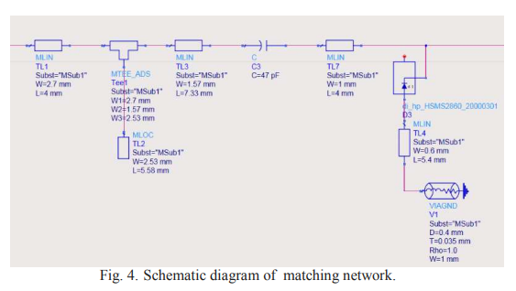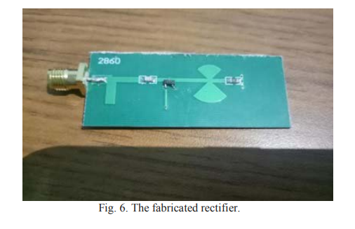

(a) (b) (c)

**(A)**

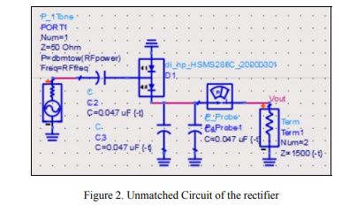 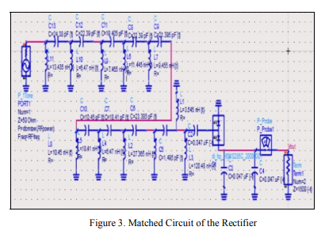

(a) (b)

**(B)**

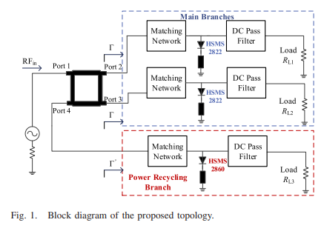

**(C)**

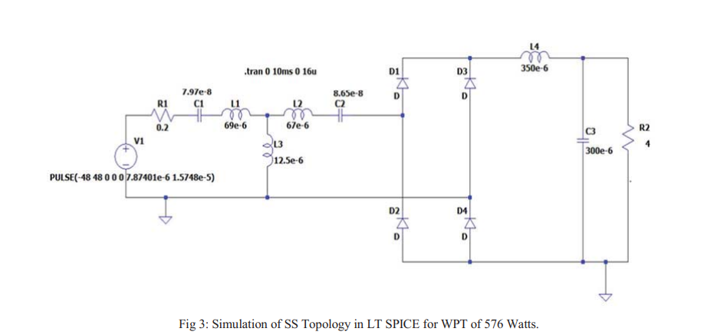

**(D)**

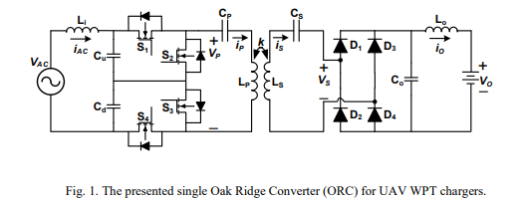

**(E)**

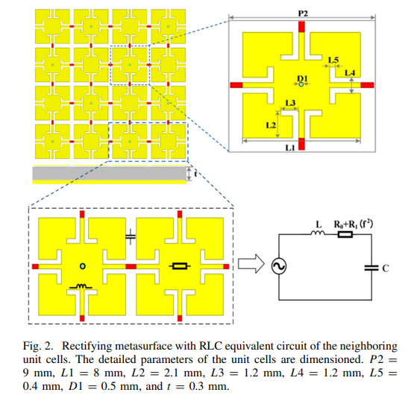

(a)

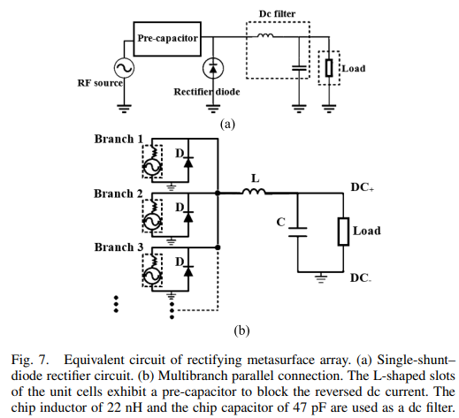

(b) (c)

**(F)**

Figure 2.5: Various Rectifier Designs for UAV Applications: (A) **:** Rectifier for RFEH with PCE 66% at 5.8 GHz [20] (a) Low Pass Filter (Harmonic Filter), (b) Matching Network and (c) Fabricated Prototype (B) Dual-Band Rectifier (2.1 GHz, 2.45 GHz and PCE = 67.26%, 51.47%) for Drone Powering Applications [21] (a) Unmatched Rectifier (b) Matched Rectifier (C) Single Band Rectifier (PCE = 50% at 2.45 GHz) with wide input power range (8.5 dBm to 32.5 dBm) [22] (D) Series-Series (SS) Topology in LT Spice for WPT of 576 Watts for UAV (PCE = 83.17% at 63.5 KHz) [23] (E) Single Oak Ridge Converter (ORC) for UAV WPT Chargers (PCE = 77% at 1 MHz) [24] (F) Rectifying Metasurface (PCE = 59.5% at 5.8 GHz) for wireless powered UAV ;(a) RLC equivalent circuit of the neighbouring unit cells (b) Single-shunt–diode rectifier circuit (c) Multibranch parallel connection[25]

**2.2.2 Performance Comparison of Existing Literature on Rectifiers for UAV Applications**

Table 2.2 compares different rectifier designs based on frequency, material/diode used, and conversion efficiency. The operating frequencies range from low values like 63.5 kHz and 1 MHz to higher frequencies like 5.8 GHz and 2.45 GHz. Various materials and diodes are used, including F4B dielectric plates, Schottky diodes (HSMS-285C, HSMS2822), GaN FETs, and polyimide substrates. Conversion efficiencies vary significantly, with the highest recorded at 83.17% for a 63.5 kHz rectifier and the lowest at 50% for a Schottky diode-based 2.45 GHz design. The table highlights the trade-offs in frequency selection, material choice, and efficiency in rectifier designs.

Table 2.2: Performance Comparison of Existing Literature on Rectifiers for UAV Applications [20-26]

|  |  |  |  |  |
| --- | --- | --- | --- | --- |
| **Ref.** | **Year of Publication** | **Frequency** | **Material/Diode** | **PCE** |
| **[20]** | 2019 | 5.8 GHz | F4B dielectric plate (2.65) | 66% |
| **[21]** | 2017 | 2.1 GHz and 2.45 GHz | Schottky Diode HSMS-285C | 67.26% and 51.47% |
| **[22]** | 2018 | 2.45 GHz | Schottky Diode HSMS2822 | 50% |
| **[23]** | 2021 | 63.5 KHz | - | 83.17% |
| **[24]** | 2020 | - | - | - |
| **[25]** | 2022 | 1 MHz | GaN FETs | 77% |
| **[26]** | 2024 | 5.8 GHz | Polyimide substrate (4.5) | 59.5% |

## 2.3 RECTENNA DESIGN FOR UAV APPLICATIONS

A rectifying antenna (rectenna) is a crucial component in wireless power transfer (WPT) systems for Unmanned Aerial Vehicles (UAVs), enabling efficient energy harvesting from electromagnetic waves. It consists of a receiving antenna that captures RF signals and a rectifier circuit that converts them into usable DC power. The design of a rectenna for UAV applications must consider factors such as compactness, lightweight structure, high RF-to-DC conversion efficiency, and optimal impedance matching to minimize power losses. Circular polarization is often preferred to enhance signal reception in dynamic environments. By integrating a rectenna into UAVs, wireless energy harvesting becomes feasible, reducing reliance on onboard batteries and extending flight endurance, making it a promising solution for long-duration aerial operations.

Different rectenna designs [27-39] used for UAV wireless power transfer applications are illustrated here. A rectenna designed for wireless power transmission in Micro Air Vehicles (MAVs) is examined in [27], featuring a half-wave dipole antenna with full-wave rectification using two diodes, achieving 66% efficiency at 200 mW input power. A UAV battery charging system utilizing a flexible rectenna array at 5.9 GHz is proposed in [28], enabling wireless charging upon landing with 5W transmit power for efficient battery replenishment. A linearly polarized 16-element antenna array with uniform amplitude and phase excitation proposed for power transmission while both a linearly and circularly polarized single element patch are proposed for reception in [29]. A compact 2.45 GHz rectenna module for UAV charging is developed in [30], integrating a 3×4 rectenna array with a power management circuit, supporting charging at 1–4m distances. Charging at 2m requires 130W transmit power, while in-flight charging at 4m necessitates a 12kW power source. In paper [31], a 28 GHz experiment attached rectennas on lower surface of drone was carried out. The result shows maximum DC output power of 24.9 mW at 0.3 m from transmitting antenna. A 500 MHz microstrip patch rectenna using an FR4 substrate is presented in [32], featuring a bridge rectifier that achieves approximately 1.1V output voltage and an S11 parameter near -20 dB. A microwave power transfer (MPT) system employing a 2.45 GHz rectenna with flat-topped beamforming is developed in [33], enhancing rectification efficiency to 68.5% with series-connected rectennas and 65.4% with parallel configurations. A lightweight 5.8 GHz rectenna weighing 0.94g is fabricated in [34], successfully delivering 1.48W DC power to a drone battery with 34.5% efficiency using a magnetron transmitter. A 28 GHz millimeter-wave wireless power transfer (WPT) system is demonstrated in [35], allowing a free-flight drone to maintain an altitude of 1.2m and operate for over 60 seconds using a PID-controlled setup. A 28GHz microwave power transmission to free flight drone experiment was conducted in [36]. A 50% maximum efficiency rectifier and single-axis beam forming system was developed. Scenarios for wireless charging of a grid of ground-based sensors from a UAV carried wireless power transfer (WPT) transmitter is discussed in [37]. Towards that end a high efficiency 900 MHz rectenna is implemented with almost 70% peak efficiency and 4.8 dBi gain for the elliptical patch. A guided drone or quadcopter or quadrotors energized by Radio Frequency Energy Harvesting was developed in [38]. A 32bit Acro Naze32 Brushed Flight Controller was used in this work as it was easier to program with the BetaFlight software and able to operate with minimal supply of 3.7 Volts. A 3-Watt independent power transmitter with frequency of 915 MHz used to test the model to supplant the encompassing accessible radio frequency resources was developed in [39].

**2.3.1 Rectenna Geometries**

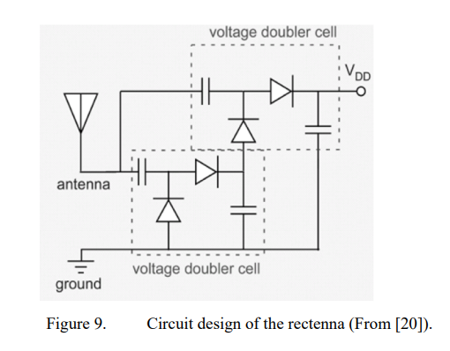 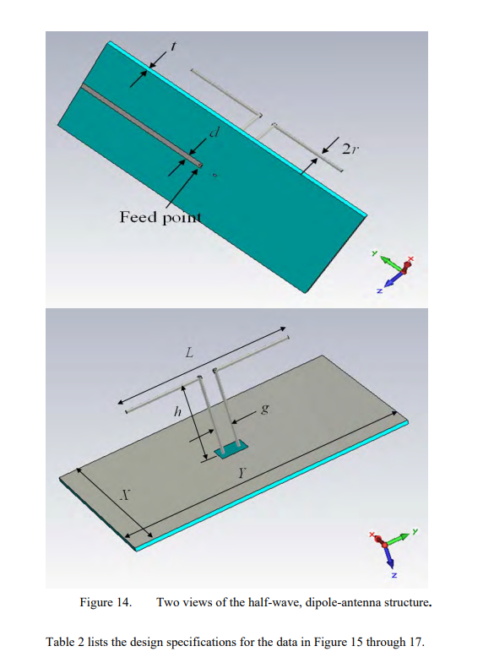

(i) (ii)

**(A)**

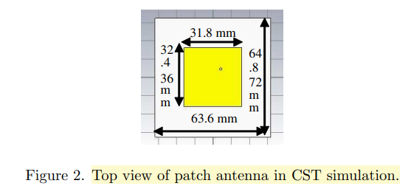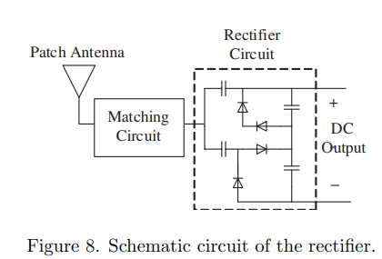

(i) (ii)

**(B)**

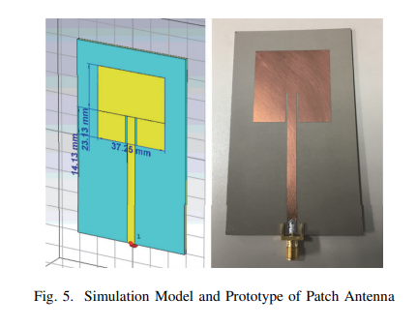 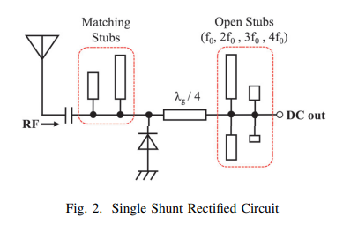

(i) (ii)

**(C)**

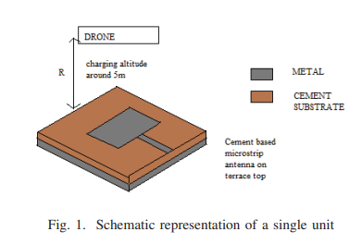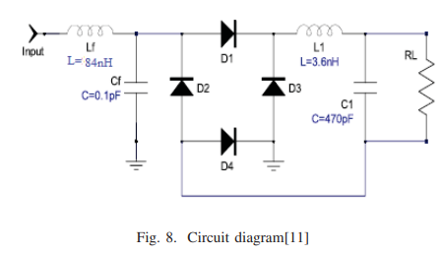

(i) (ii)

**(D)**

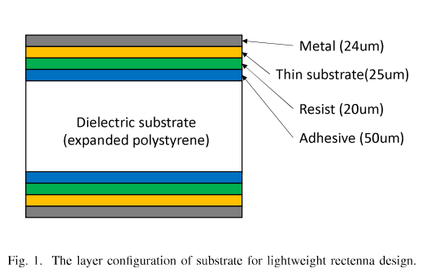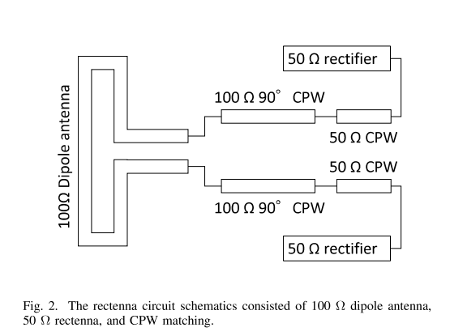 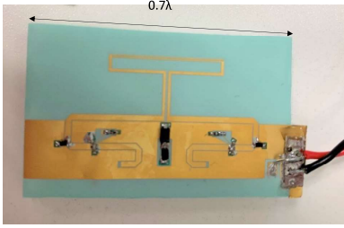

(i) (ii) (iii)

**(E)**

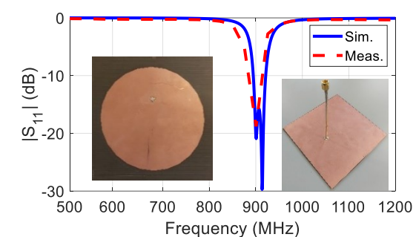 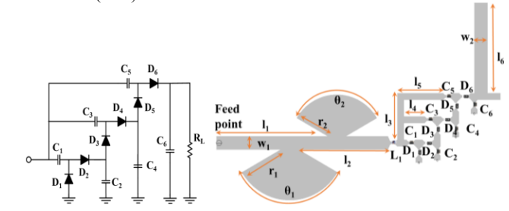

(i) (ii) (iii)

**(F)**

Figure 2.6:Various Rectenna Geometry for UAV applications(A) WPT Rectenna for UAV (10 GHz) [24] (i) Rectifier (PCE = 65%) (ii) Dipole Antenna (B) WPT Battery Charging System [30] (i) Top-view of patch antenna (2.45 GHz) and (ii) Rectifier Schematic (PCE = 46.5%) (C) Rectenna for UAV (2.45 GHz) [31]; (i) Patch Antenna Simulation Model with and Prototype (ii) Single Shunt Rectifier (PCE = 50%) (D) Low Frequency Rectenna for Wireless Charging of Unmanned Aerial Vehicles [33]; (i) single unit microstrip antenna (500 MHz) and (ii) Rectifier with PCE = 40% (E) Lightweight rectenna for MPT to flying objects[35] (i)The layer configuration of substrate for lightweight antenna (5.8 GHz) design (ii) The rectenna circuit schematics consisted of 100 Ohm dipole antenna, 50 Ohm rectifier(PCE=53.7%) and CPW matching(iii) Fabricated lightweight rectenna on the FPC with 34.5% efficiency(F) Rectenna for Wireless Charging of Ground-based Sensors from a UAV-carried Transmitter [37]; (i) S11 Performance of the fabricated 900 MHz UHF antenna and (ii) Voltage multiplier (multi-stage) rectifier (PCE = 70%) and (iii) the geometry of the proposed 900 MHz rectifier.

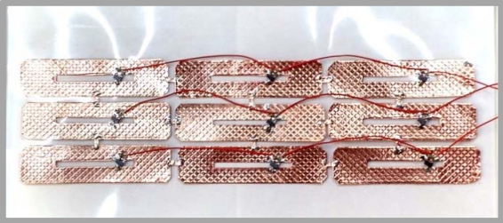 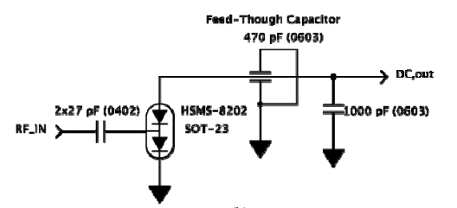

(i) (ii)

**(A)**

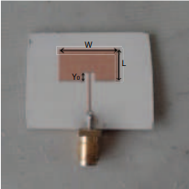 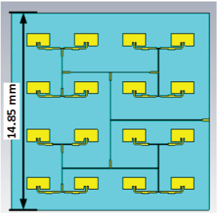

(i) (ii)

**(B)**

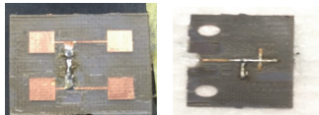

(i) (ii)

**(C)**

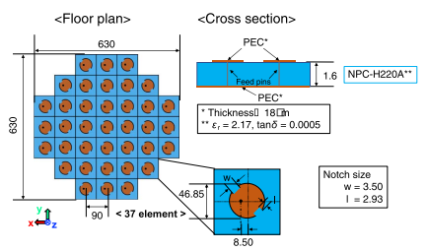 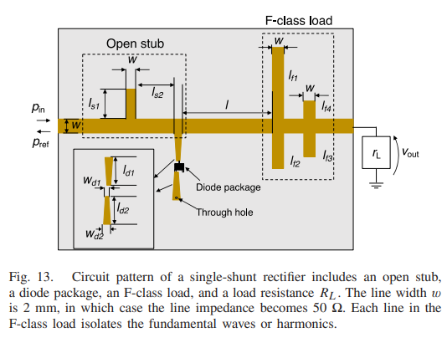

(i) (ii)

**(D)**

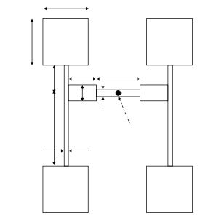 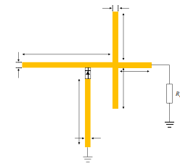

(i) (ii)

**(E)**

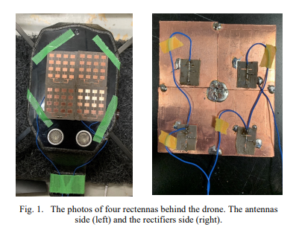

(i) (ii)

**(F)**

Figure 2.7**:** Various Rectenna Array Geometry for UAV applications(A) Rectenna Array for micro-UAV (5.9 GHz) [28] (i) Array of 2D Slotted Antennas (ii) Schematic of the dual-diode “charge-pump” Rectifier (PCE = 56.5%) (B) Transmitter-Receiver System for MPT UAV system (5.8 GHz) [29] (i) Single transmitter’s patch antenna and (ii) 16-Element Array Elements (C) 28 GHz Rectenna for UAV [32] (i) Fabricated antenna and (ii) Fabricated rectifier (PCE = 55.5%)(D) Rectenna for UAV Applications [34]; (i) 37-element Rx array (2.45 GHz) of the MSA and (ii) Single-shunt rectifier (PCE = 60%) for UAV(E) Rectenna for Power Beaming to Free Flight Drone [36]; (i) Four Element Microstrip Patch Antenna Array (28 GHz) and (ii) Single-Shunt Rectifier Circuit (PCE = 55.5%) (F) The photos of four rectennas behind the drone for wireless charging of hovering drone via mm wave[39]. (i)antennas side(28 GHz) and (ii)rectifiers side (PCE=55.5%) for wireless charging of drone via mm wave.

**2.3.3 Performance Comparison of Rectenna Designs for UAV Application**

The table compares different rectenna designs for UAV applications based on frequency, gain, substrate height, and rectifier efficiency. The operating frequencies range from 2.45 GHz to 28 GHz, with one design at 350 THz. Gain values vary from 6 dBi to 18.71 dBi, depending on the design. Substrate heights range from 0.508 mm to 50 nm, reflecting different material choices. Rectifier efficiency varies, with the highest recorded at 65% for a 10 GHz design and the lowest at 46.5% for a 2.45 GHz design. The table highlights the performance variations across different frequency bands

Table 2.3: Rectenna Performance Comparison [27-39]

|  |  |  |  |  |  |  |  |  |
| --- | --- | --- | --- | --- | --- | --- | --- | --- |
| **Ref.** | **Year of Publication** | **Frequency** | **Gain** | **Antenna**  **Dimension** | **Substrate used(antenna)** | **Substrate**  **Thickness** | **Diode/Substsrate**  **Used** | **Rectifier Efficiency** |
| **[27]** | 2011 | 10 GHz | 6.26 dBi | 25×35 mm2 | Rogers Duroid 5880 | 0.508 mm | HMS2820 | 65% |
| **[28]** | 2015 | 5.9 GHz | - | - | - | - | HMS8101 | 56.5% |
| **[29]** | 2015 | 5.8 GHz | 5.3 dBi | 14.8×14.85 mm2 | Rogers RO3006 (6.15) | 1.27 mm | - | 34-90% |
| **[30]** | 2017 | 2.45 GHz | 6.85 dBi | 63.6×64.8 mm2 | RO4003 (3.38) | 1.524 mm | SMS7630 | 46.5% |
| **[31]** | 2018 | 2.45 GHz | 7.6 dBi | 23.13×37.25 mm2 | - | - | - | 50% |
| **[32]** | 2018 | 28 GHz | 8.47 dBi | - | DiClad 880 (2.2) | - | MA4E1317 | 55.5% |
| **[33]** | 2020 | 500 MHz | 8 dBi | 137.5×182.6 mm2 | FR4 (4.4) | 1.6 mm | HSMS285 | 40% |
| **[34]** | 2020 | 2.45 GHz | 8.4dBi | 630×630 mm2 | NPC-F260A(2.17) | 1.6 mm | NPC-F260A | 60% |
| **[35]** | 2021 | 5.8 GHz | - | - | RF705S(3.4) | - | DGKF201, DENGYO | 53.7% |
| **[36]** | 2021 | 28 GHz | 4 dBi | 18×15 mm2 | DiClad 880 (2.2) | - | MA4E1317 | 55.5% |
| **[37]** | 2021 | 900 MHz | 4.8 dBi | - | FR4 (4.4) | 1.5 mm | - | 70% |
| **[38]** | 2021 | 915 MHz | 4.1 dBi | - | - | - | - | - |
| **[39]** | 2022 | 28 GHz | 18.71 dBi | 30×30 mm2 | DiClad880(2.2) | - | - | 55.5% |

# 3. METHODOLOGY

## 3.1 ANTENNA DESIGN

In this work, we used a microstrip patch antenna as the base for our antenna design due to its advantages in compactness, ease of fabrication, and suitability for high-frequency applications. Microstrip antennas consist of a metallic radiating patch mounted on a dielectric substrate with a ground plane on the opposite side. These antennas are commonly fed using coaxial probes, microstrip lines, or aperture coupling methods.

*Figure SEQ Figure \* ARABIC 1: Simple coaxial probe feed microstrip antenna (image source: researchgate)*

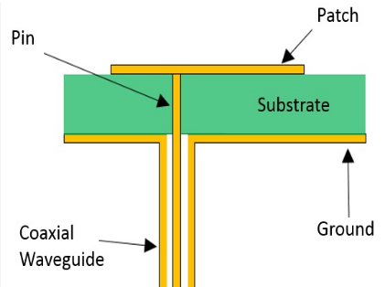

Fig 3.1.1: A Simple Coaxial Probe Feed Microstrip antenna(image source- researchgate)

Initially, the antenna design was inspired from [36] that utilized a 2×2 square patch microstrip antenna array operating at 28 GHz. This array served as a foundational model due to its well-documented performance characteristics. The reference design offered a strong starting point in terms of compactness and gain.

**Design Details**

Operating Frequency: 28 GHz

Substrate Material: DiClad 880

Dielectric Constant (εr): 2.2

Substrate Thickness (h): 0.508 mm

Patch Size (each element): 3.2 mm × 3.2 mm

Feeding Method: Coaxial probe feed

round Plane: Full ground plane, same as substrate size

Overall Array Dimensions: 18 mm × 15 mm

Polarization: Linear

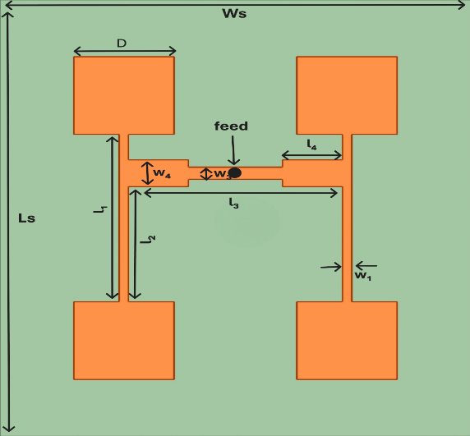

Figure 3.1.2: 2X2 Coaxial Probe Feed Square Patch Antenna Array Geometry

Table 3.1.1: 2X2 Coaxial Probe Feed Square Patch Antenna Array Dimensions (Unit: mm)

|  |  |
| --- | --- |
| Substrate Length (Ls) | 18 |
| Substrate Width (Ws) | 15 |
| D | 3.2 |
| l1 | 6.9 |
| l2 | 3.9 |
| l3 | 6.8 |
| l4 | 1.9 |
| w1 | 0.3 |
| w3 | 0.5 |
| w4 | 1.1 |

**3.1.1 Performance Comparison**

To verify its performance and understand the baseline characteristics, the 2×2 array was replicated in simulation software (HFSS), using the same substrate and dimensions as specified in the paper. This step ensured that the simulation environment was properly configured and allowed for benchmarking against future modifications.

To explore performance improvements and compactness, the square patch was systematically replaced with two alternative geometries circular and triangular while keeping other parameters such as substrate material, thickness, and ground dimensions constant.

 

(a) Square (b) Circular (c) Triangular

Figure 3.1.3: Different Patch Structures of Equal Area

Table 3.1.2: Performance Comparison of Square, Circular and Triangular Patch Antenna Array

|  |  |  |  |
| --- | --- | --- | --- |
|  | **Square** | **Circular** | **Triangular** |
| **Resonance Freq(GHz)** | 28.2 | 30.6 | 25.8 |
| **S11(dB)** | -23 | -20.7 | -17.2 |
| **Gain(dB)** | 11.54 | 11.26 | 11.4 |
| **Bandwidth(dB)** | 1.15 | 1.30 | 1.22 |
| **Axial Ratio(dB)** | 44.6 | 58.6 | 55 |

Above table shows that each structure exhibits a high axial ratio, indicating linear polarization. All three have similar gain values, but the triangular patch shows a left-shifted resonance frequency, suggesting potential for further size reduction. Hence, the triangular patch was selected.

**3.1.2 Inter-Patch Distance Optimization**

Following the selection of the triangular patch geometry, the next phase involved the optimization of inter-element spacing between adjacent triangular patches along the length of the antenna array. The goal was to achieve a more compact design without significantly compromising the antenna’s performance.

The primary objective of this step was to reduce the overall array length by minimizing the center-to-center distance between adjacent patch elements, while ensuring acceptable levels of:

* Return Loss (S11)
* Gain

Initially, the spacing was 7.29 mm based on the standard design. From this baseline, a parametric study was conducted by gradually decreasing the spacing to observe the effect on impedance matching and radiation performance.

The results of this study are summarized below:

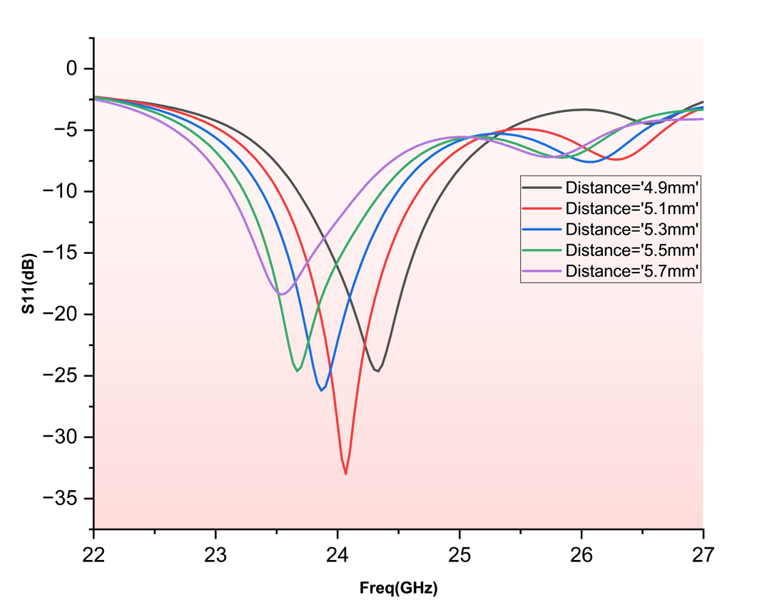

Figure 3.1.4: S11 vs Frequency Curve for Different Inter-Patch Distance

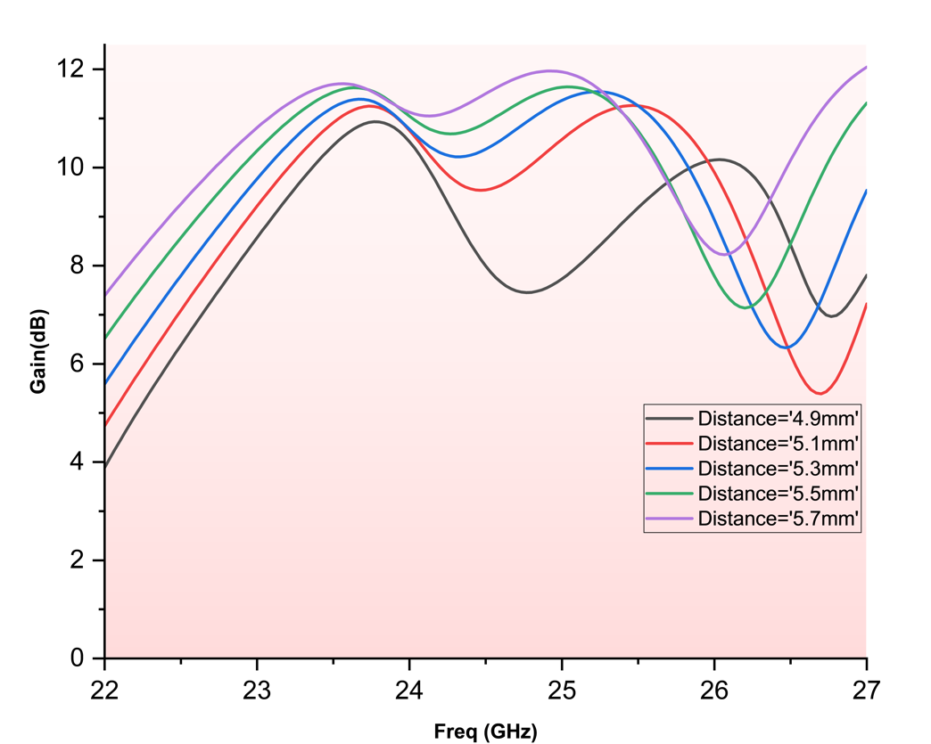

Figure 3.1.5: Gain vs Frequency Curve for Different Inter-Patch Distance

Table 3.1.3: Performance Comparison of Antenna Array for Different Inter-Patch Distance

|  |  |  |  |
| --- | --- | --- | --- |
| **Patch Spacings(mm)** | **Resonance Frequency(GHz)** | **S11(dB)** | **Gain(dB)** |
| 4.9 | 24.33 | -25.58 | 10.10 |
| 5.1 | 24.1 | -35.38 | 10.71 |
| 5.3 | 23.86 | 29.27 | 10.73 |
| 5.5 | 23.66 | -23.84 | 10.95 |
| 5.7 | 23.46 | -19.06 | 10.98 |

From Table 3, it can be observed that there is no significant reduction in gain till patch spacing of 5.1 mm, so this value was selected to move forward.

**3.1.3 Circular Polarization and Slot Introduction**

Circular polarization (CP) occurs when the electric field of an electromagnetic wave rotates in a circular motion as it propagates. Unlike linear polarization (where the electric field oscillates in one fixed direction), CP allows the wave to maintain consistent performance regardless of orientation between the transmitting and receiving antennas.

Linear polarization (LP) antennas offer greater range but suffer from reduced orientation flexibility, leading to lower received power in dynamic scenarios such as wearable devices. In contrast, circular polarization (CP) antennas provide better orientation independence, reducing fading and multipath interference. This improves system efficiency by minimizing polarization mismatch and enhancing signal reception. While LP antennas are more commonly used, novel CP antenna designs have demonstrated superior performance in RF energy harvesting (RFEH) and wireless power transfer (WPT) applications.

The axial ratio quantifies how close the polarization is to being circular. It is defined as the ratio of the major axis to the minor axis of the polarization ellipse.

* Perfect circular polarization: Axial Ratio = 1 (0 dB)
* Good circular polarization: Axial Ratio ≤ 3 dB

To achieve circular polarization, a diagonal slot was introduced at the center of each triangular patch in the array. This technique is known to perturb the current distribution and excite two orthogonal modes with a 90° phase difference which is an essential condition for circular polarization.

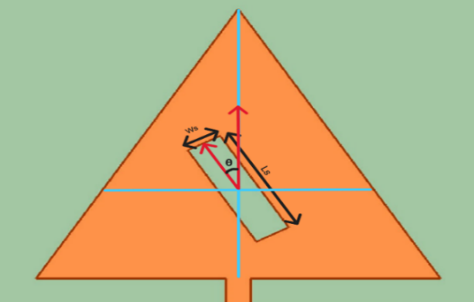A rectangular slot of fixed width 0.45 mm was etched at an angle of 45° from the vertical axis of the patch. The length of the slot was treated as a tunable parameter to control the mode balance and optimize the axial ratio (AR).

The objective was to achieve an axial ratio ≤ 3 dB, indicating effective circular polarization.

Figure 3.1.6: Slot at Centroid of Triangular Patch

**Slot Length Variation**

A parametric sweep of slot length was performed, ranging from 1.55 mm to 1.75 mm in steps of 0.05 mm. For each slot length, the following parameters were evaluated:

* Axial Ratio (AR)
* Resonant frequency
* Gain

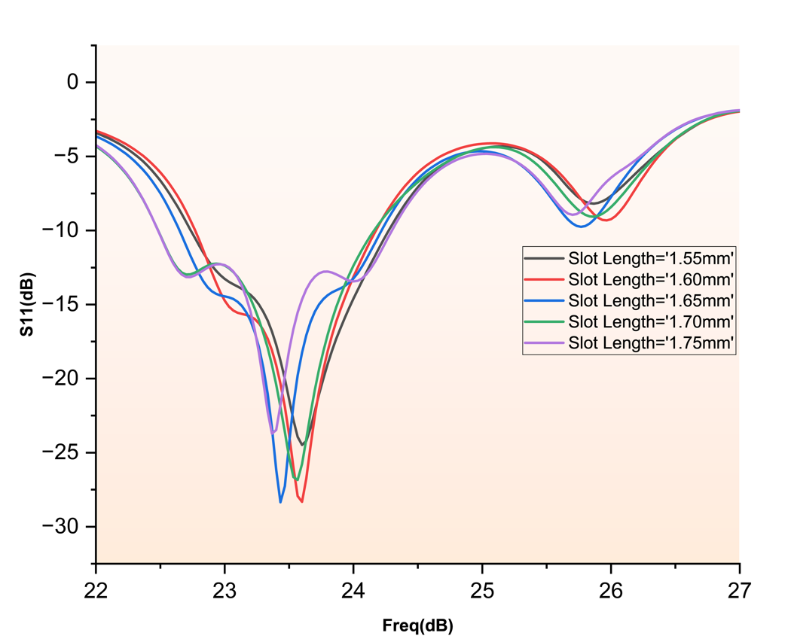

Figure 3.1.7: S11 vs Frequency Curve for Various Slot Length

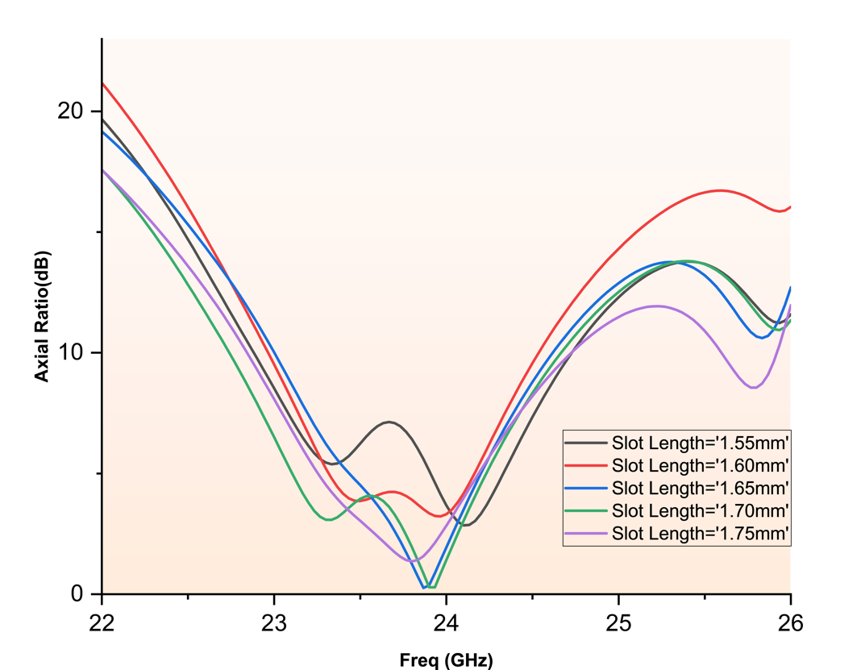

Figure 3.1.8: Axial Ratio vs Frequency Curve for Various Slot Length

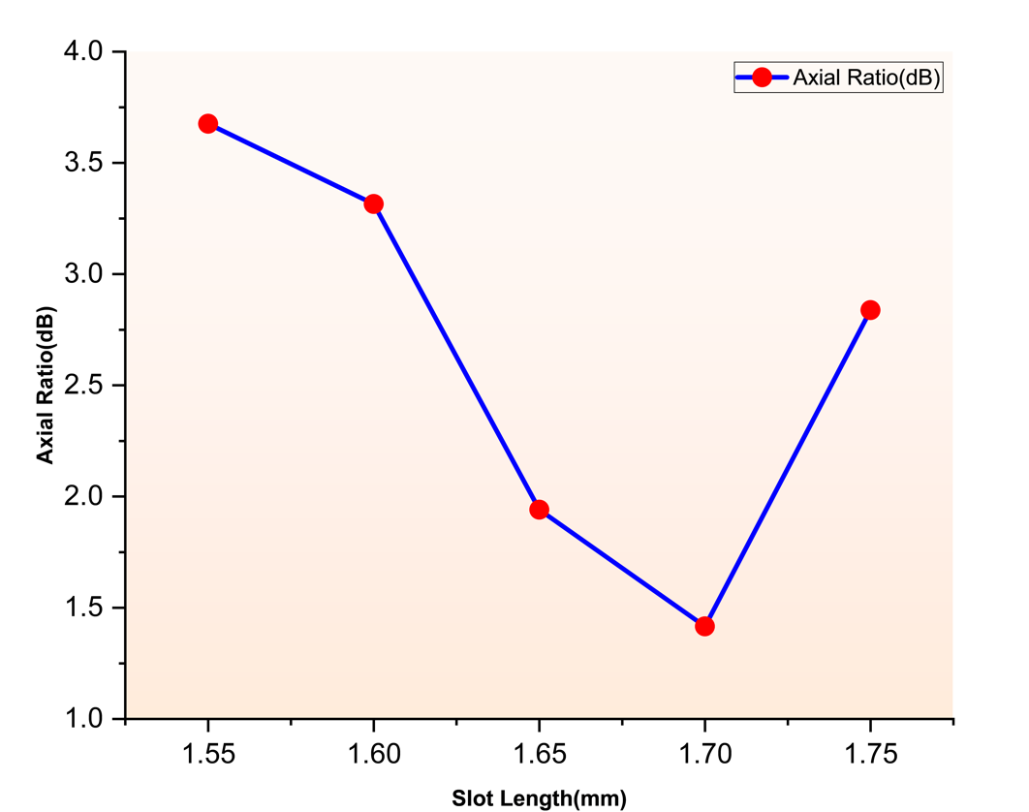

Figure 3.1.9: Axial Ratio at 24 GHz vs Slot Length

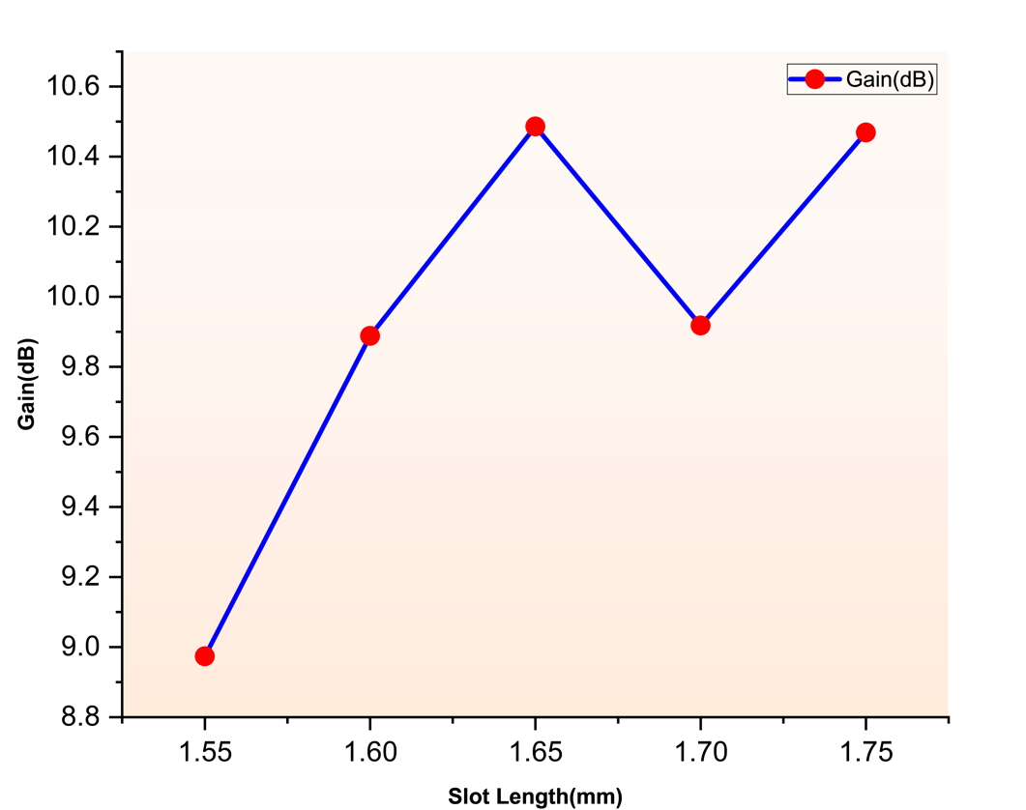

Figure 3.1.10: Gain at 24 GHz vs Slot Length

Table 3.1.4: Gain and Axial Ratio at 24 GHz for Different Slot Length

|  |  |  |
| --- | --- | --- |
| **Slot Length(mm)** | **Gain(dB)** | **Axial Ratio(dB)** |
| 1.55 | 8.97 | 3.60 |
| 1.60 | 9.88 | 3.30 |
| 1.65 | 10.48 | 1.94 |
| 1.70 | 9.91 | 1.41 |
| 1.75 | 10.46 | 2.83 |

From this sweep, a slot Length of 1.65 mm was selected as optimal, providing the low axial ratio (1.9 dB) along with high gain (10.48 dB).

**Slot Width Variation**

After identifying the optimal slot length of 1.65 mm, the next refinement step aimed to further reduce the axial ratio by tuning the slot width, while keeping the slot length and orientation fixed.

The slot width was varied from 0.35 mm to 0.55 mm, in increments of 0.05 mm.

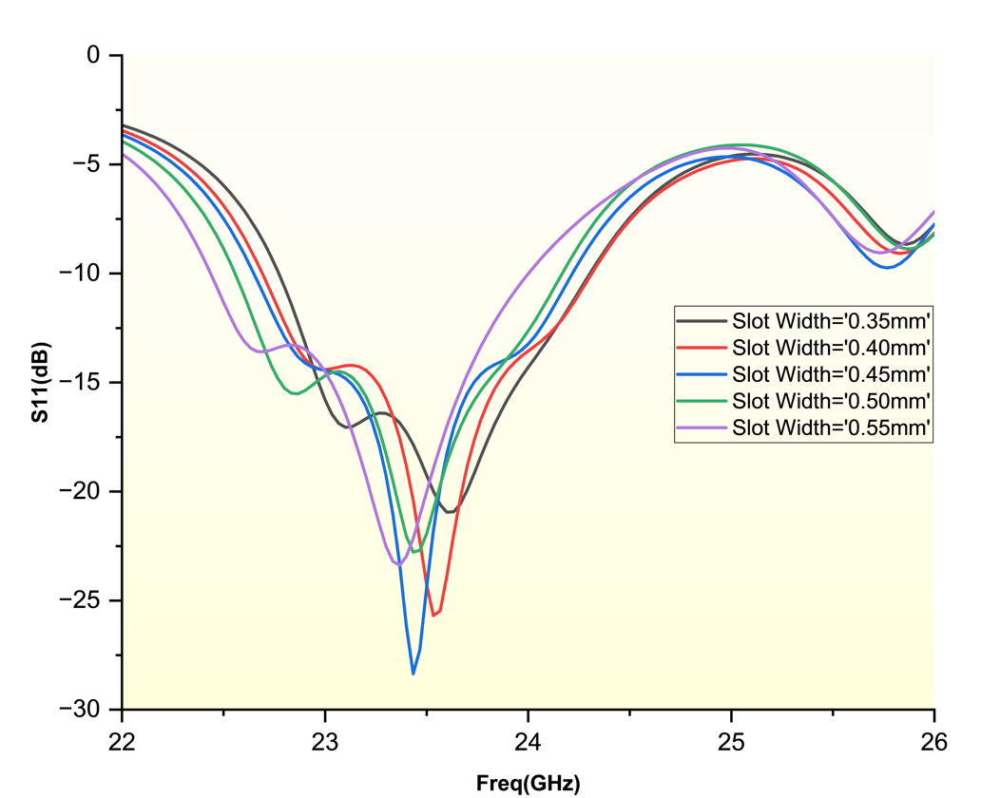

Figure 3.1.11: S11 vs Frequency Curves for Various Slot Width

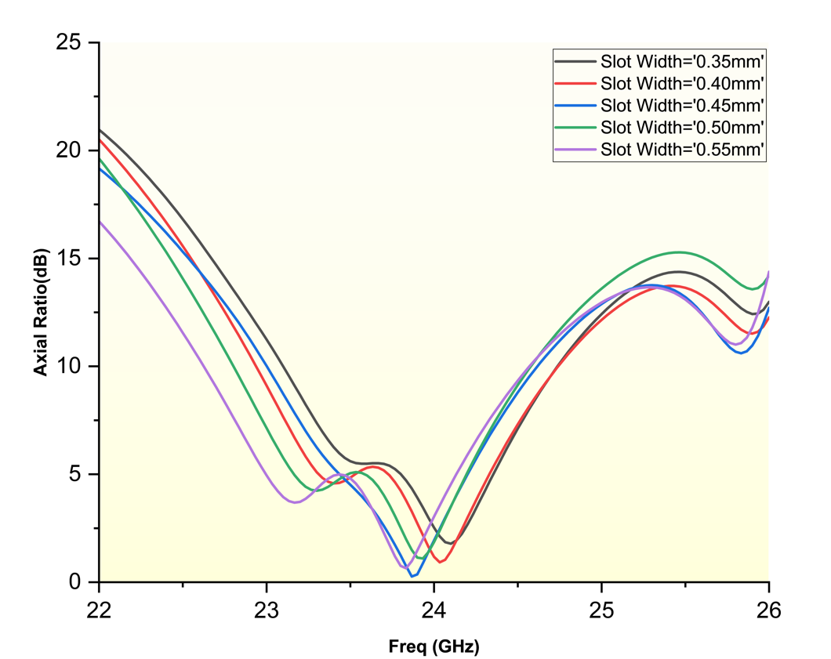

Figure 3.1.12: Axial Ratio vs Frequency Curves for Various Slot Width

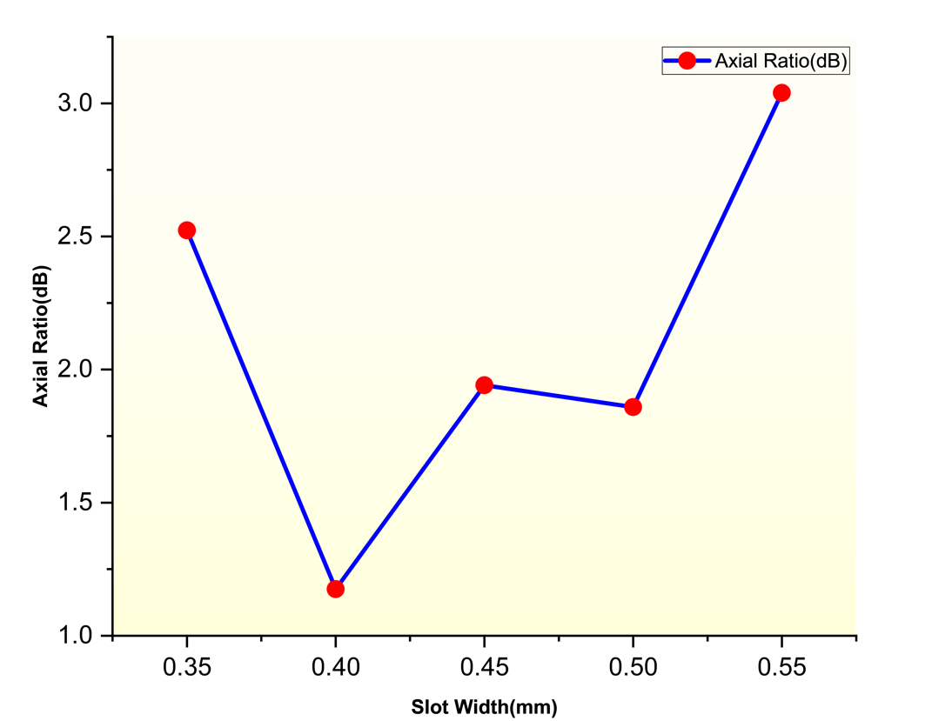

Figure 3.1.13: Axial Ratio vs Slot Width Curve

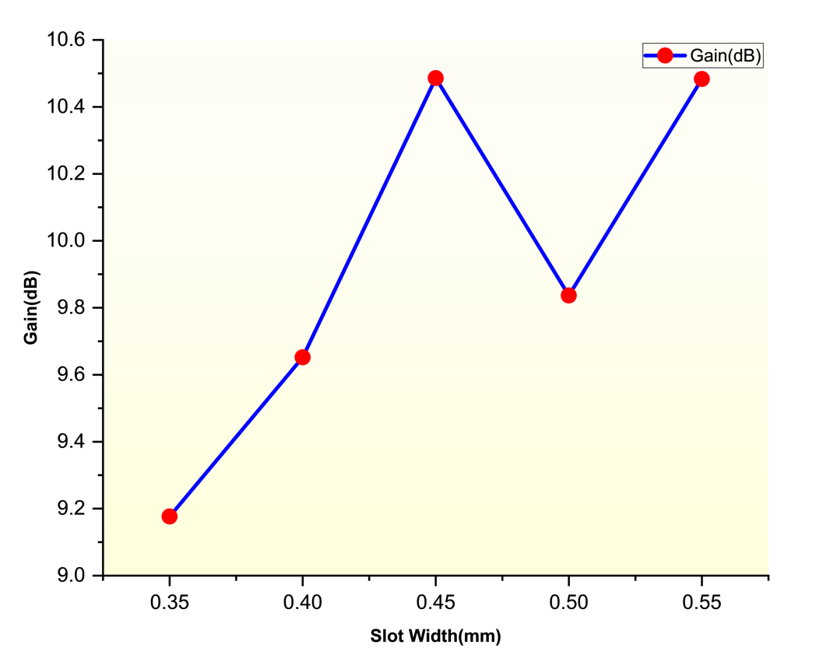

Figure 3.1.14: Gain vs Slot Width Curve

Table 3.1.5: Gain and Axial Ratio at 24 GHz for Different Slot Width

|  |  |  |
| --- | --- | --- |
| **Slot Width(mm)** | **Gain(dB)** | **Axial Ratio(dB)** |
| 0.35 | 9.10 | 2.52 |
| 0.40 | 9.65 | 1.17 |
| 0.45 | 10.40 | 1.94 |
| 0.50 | 9.83 | 1.85 |
| 0.55 | 10.48 | 3.03 |

From this sweep, a slot width of 0.45 mm was selected as optimal, providing the lowest axial ratio (1.94 dB) along with good resonance and gain.

**3.1.4 Feed Position Optimization**

After achieving circular polarization through slot loading, the next design phase involved optimizing the position of the coaxial feed to:

* Achieve resonance near the target frequency of 24 GHz
* Maximize gain and impedance matching (S11)

This optimization was performed in two steps, as outlined below:

**Feed Position Sweep on Initial Patch**

Initially, the feed location was varied on the triangular patch to observe its effect on resonance and return loss. Multiple feed positions were simulated by shifting the feed point across different radial and angular locations from the patch center.

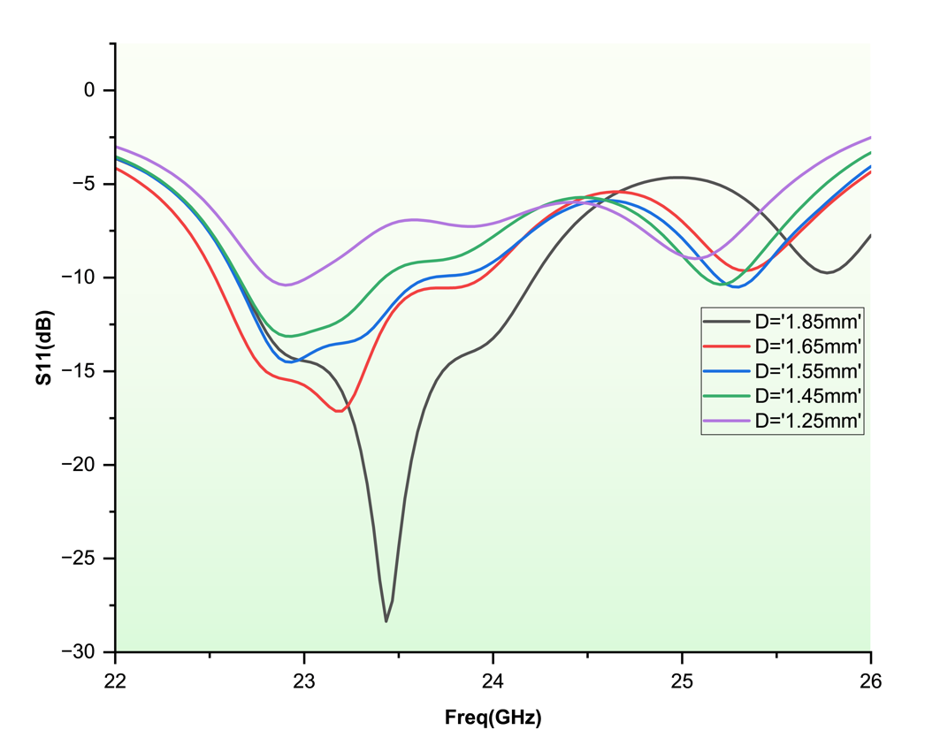

Figure 3.1.15: S11 vs Frequency Curves for Various Feed Position Before Patch Dimension Reduction

However, for all tested positions, the resonant frequencies were observed to be below 24 GHz, indicating that feed position adjustment alone was insufficient to achieve the desired resonance.

**Patch Dimension Reduction and Feed Re-Optimization**

To shift the resonant frequency upward towards 24 GHz, the dimensions of the triangular patch were reduced, the distance between vertex and centroid was decreased from 2.81 mm to 2.71 mm. This modification effectively increased the patch’s resonant frequency due to the inverse relationship between patch size and resonant frequency.

After resizing the patch, a new parametric sweep of feed positions was conducted. The slot feed position was varied from 1.25 mm to 1.85 mm vertically upward from center of antenna, in increments of 0.1 mm. For each position, the following results were obtained:

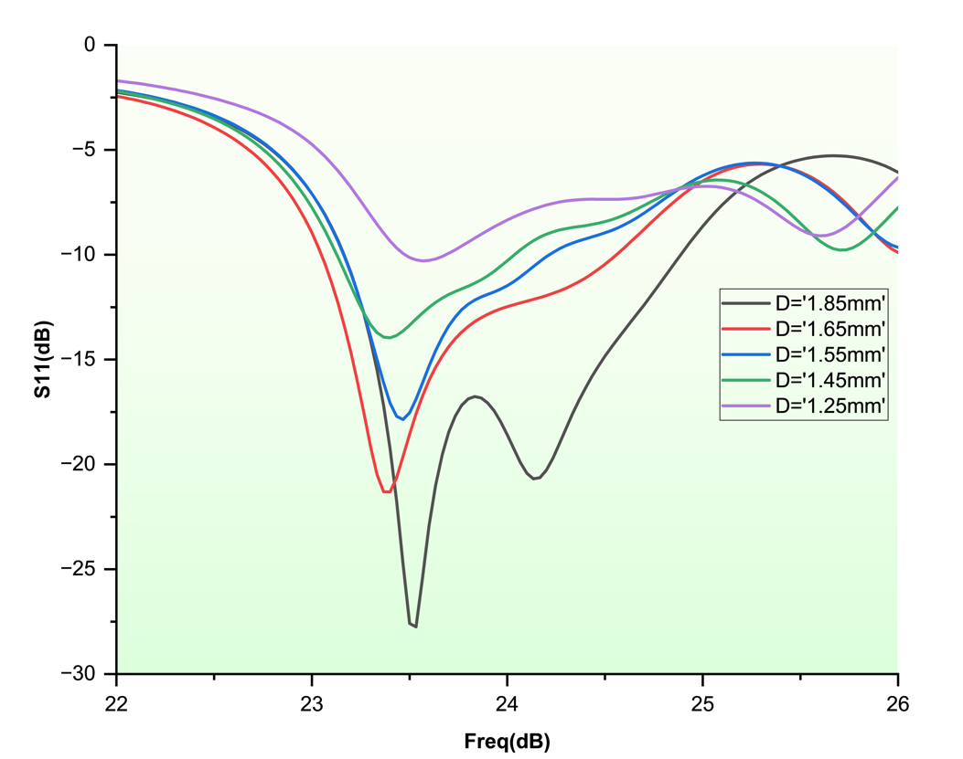

Figure 3.1.16: S11 vs Frequency Curves for Various Feed Position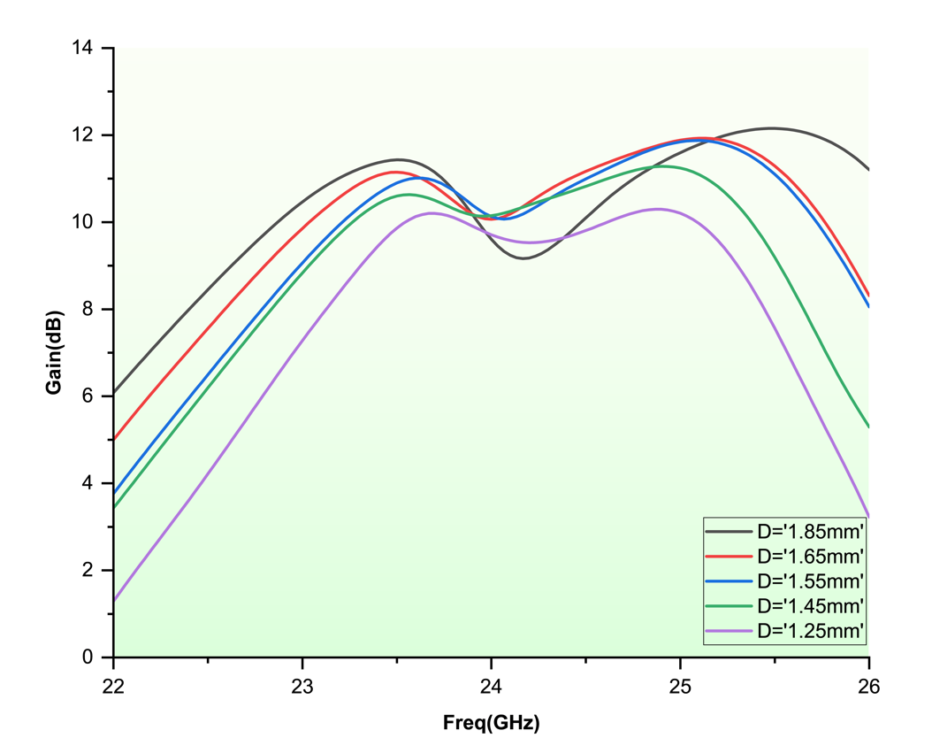Figure 3.1.17: Gain vs Frequency Curves for Various Feed Position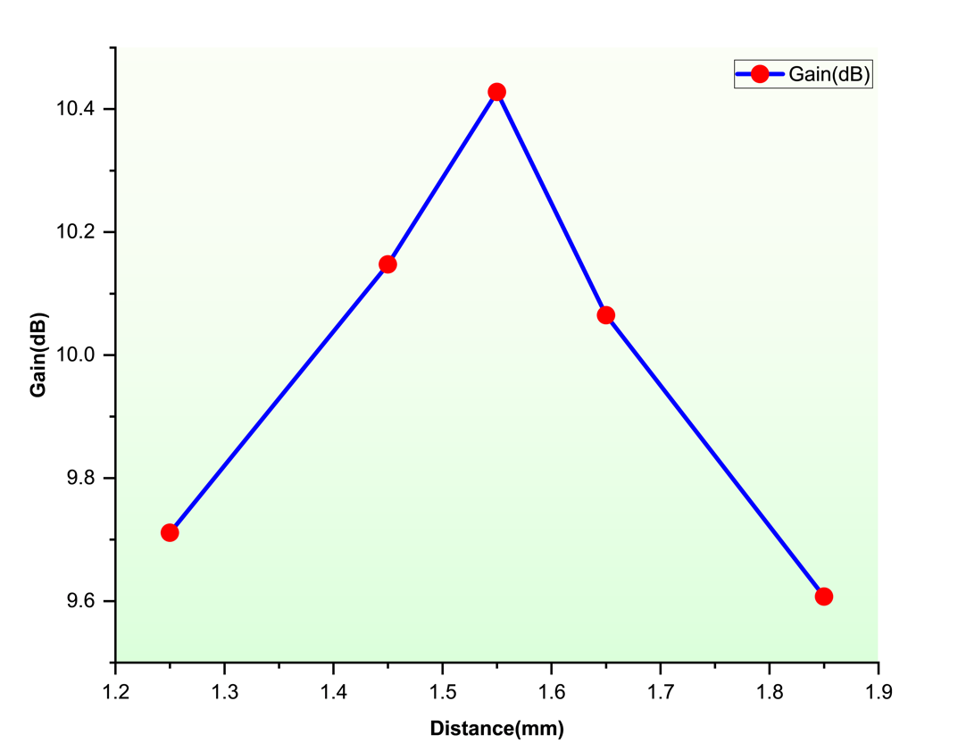

Figure 3.1.18: Gain Vs Feed Position From Center of Antenna

Table 3.1.6: Antenna Array Gain for Various Feed Position

|  |  |
| --- | --- |
| **Distance(mm)** | **Gain(dB)** |
| 1.25 | 9.71 |
| 1.45 | 10.14 |
| 1.55 | 10.42 |
| 1.65 | 10.06 |
| 1.85 | 9.60 |

From Table 3.1.6, it can be observed that antenna array gain is maximum at feed position of 1.55 mm form center.

**3.1.5 Slot Angle Modification**

With the slot length fixed at 1.65 mm and width at 0.45 mm, the next refinement step aimed to further minimize the axial ratio at 24 GHz by varying the orientation angle of the slot with respect to the vertical axis.

A range of slot angles was tested, from 0° to 90° in increments of 5°, while maintaining the slot’s center position. For each angle, the following were evaluated:

* Axial Ratio (AR)
* Gain
* Return Loss (S11)

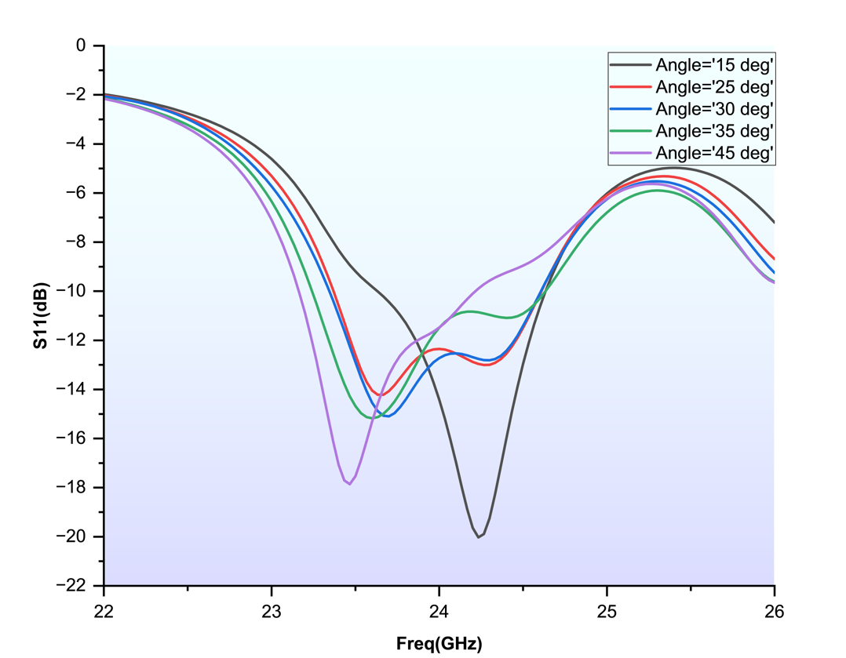

Figure 3.1.19: S11 vs Frequency Curves for Various Slot Angle

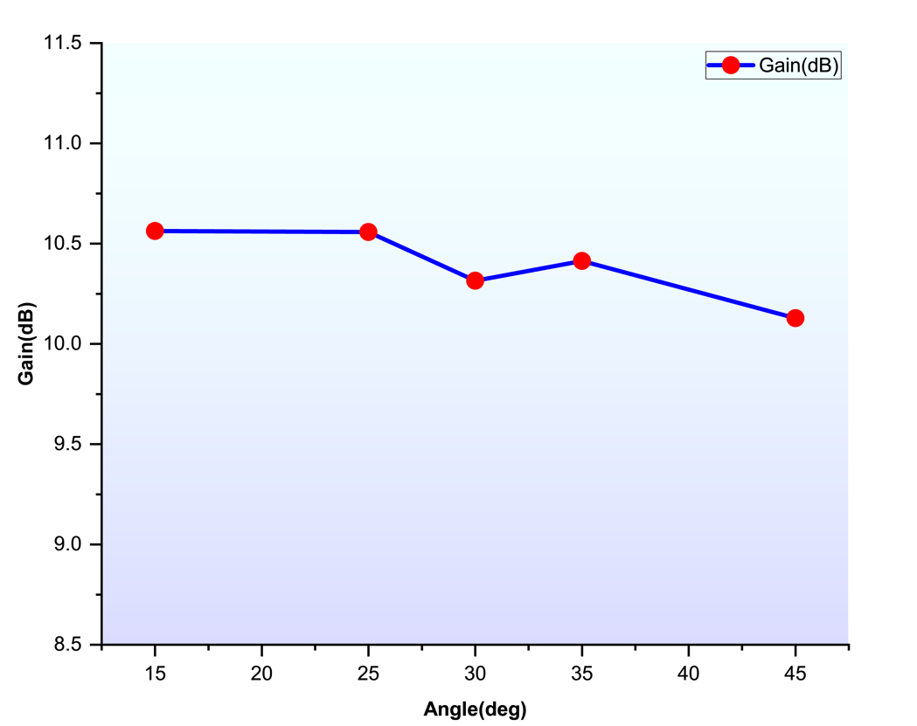

Figure 3.1.20: Gain vs Slot Angle Curve

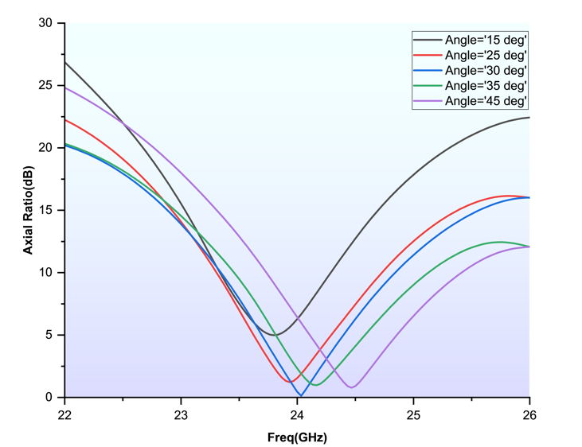

Figure 3.1.21: Axial Ratio vs Frequency Curve for Various Slot Angle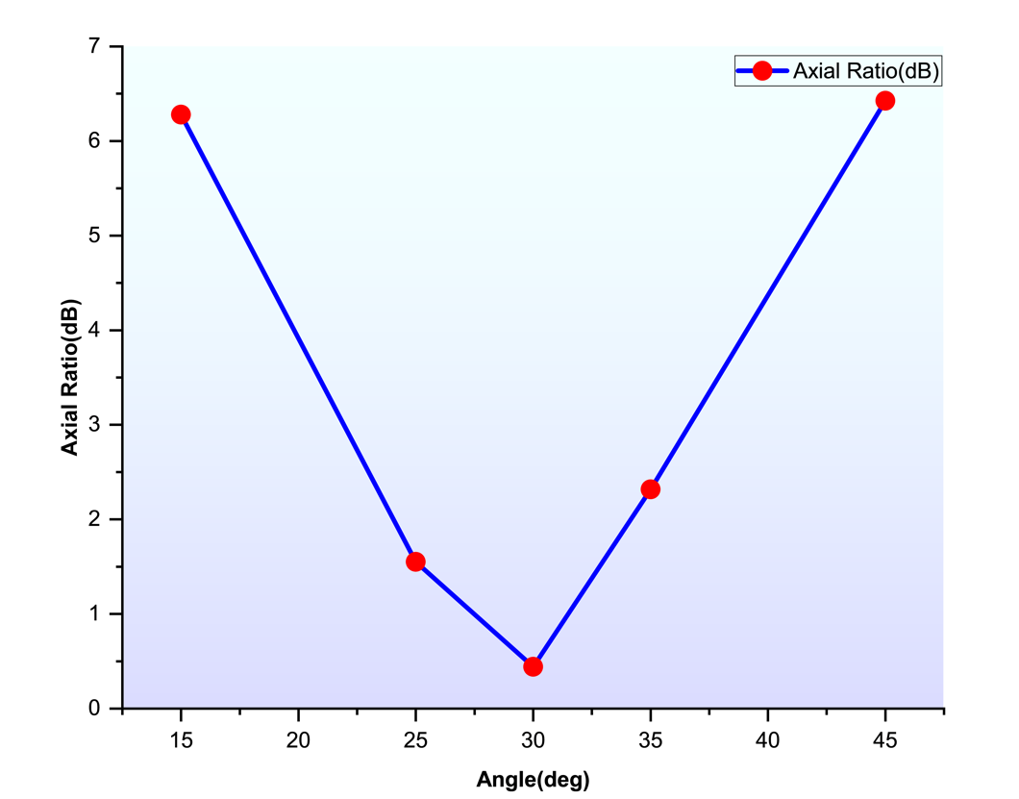

Figure 3.1.22: Axial Ratio vs Slot Angle Curve

Table 3.1.7: Gain and Axial Ratio for Various Slot Angle

|  |  |  |
| --- | --- | --- |
| **Slot angle(degree)** | **Gain(dB)** | **Axial Ratio(dB)** |
| 15 | 10.56 | 6.27 |
| 25 | 10.55 | 1.55 |
| 30 | 10.35 | 0.44 |
| 35 | 10.41 | 2.31 |
| 45 | 10.12 | 6.42 |

From Table 3.1.7, slot angle of 30 degree is selected because it gives minimum axial ratio of 0.44 dB.

**3.1.6 Substrate Dimension Reduction**

To further enhance the antenna's compactness, the dimensions of the dielectric substrate were optimized. The goal was to minimize substrate length and width while maintaining satisfactory performance in terms of gain, return loss, and axial ratio.

This optimization was done in two steps: first by reducing the substrate length, followed by reduction of the substrate width.

**Substrate Length Variation**

In this step, the substrate length was gradually reduced from the original value. For each reduced length, key antenna performance parameters S11, gain, and axial ratio were evaluated. The reduction continued until any further decrease caused significant drop in gain.

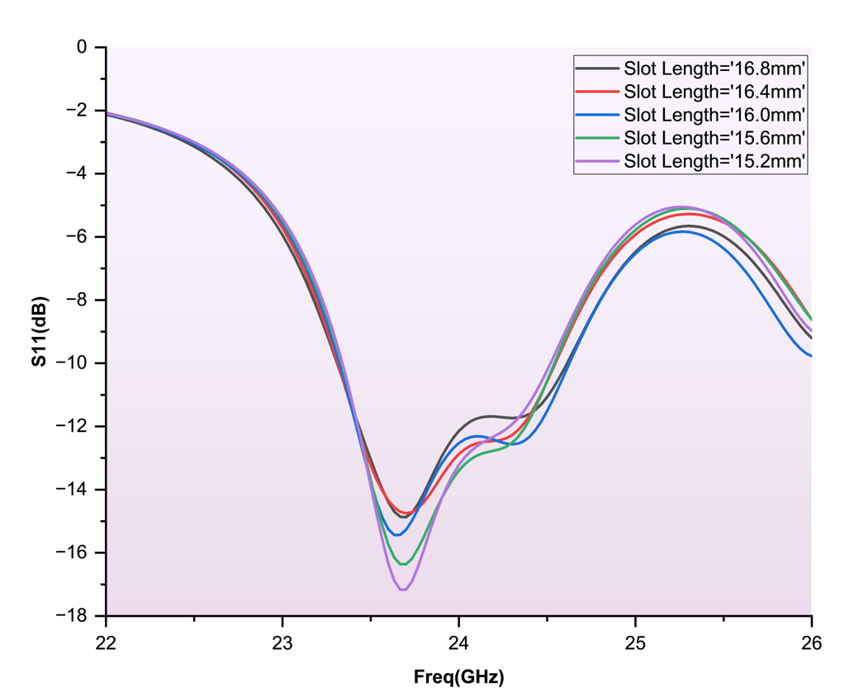

Figure 3.1.23: S11 Vs Frequency Curves for Various Substrate Length

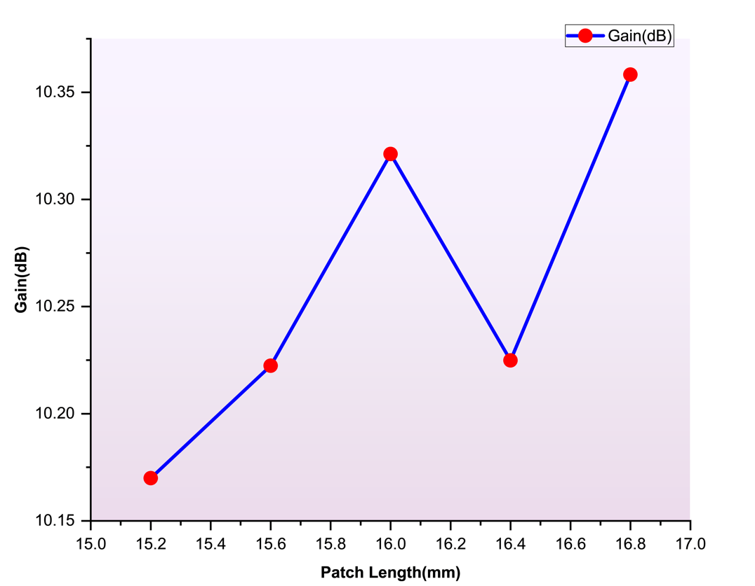

Figure 3.1.24: Gain vs Substrate Length Curve

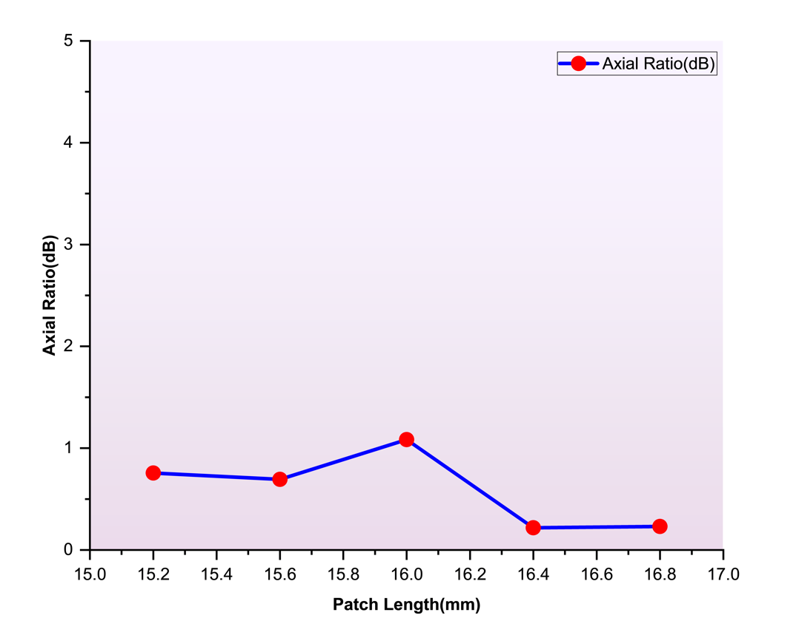

Figure 3.1.25: Axial Ratio vs Substrate Length Curve

Table 3.1.8: Gain and Axial Ratio Value for Various Substrate Length

|  |  |  |
| --- | --- | --- |
| **Substrate Length(mm)** | **Gain(dB)** | **Axial Ratio(dB)** |
| 16.8 | 10.35 | 0.23 |
| 16.4 | 10.2 | 0.21 |
| 16.0 | 10.3 | 1.08 |
| 15.6 | 10.2 | 0.69 |
| 15.2 | 10.16 | 0.75 |

Once the minimum viable length was identified (i.e. 16 mm), the substrate width was gradually reduced following a similar approach.

The width was decreased in steps, and performance metrics were monitored. Reduction was stopped once further decrease began to degrade antenna characteristics.

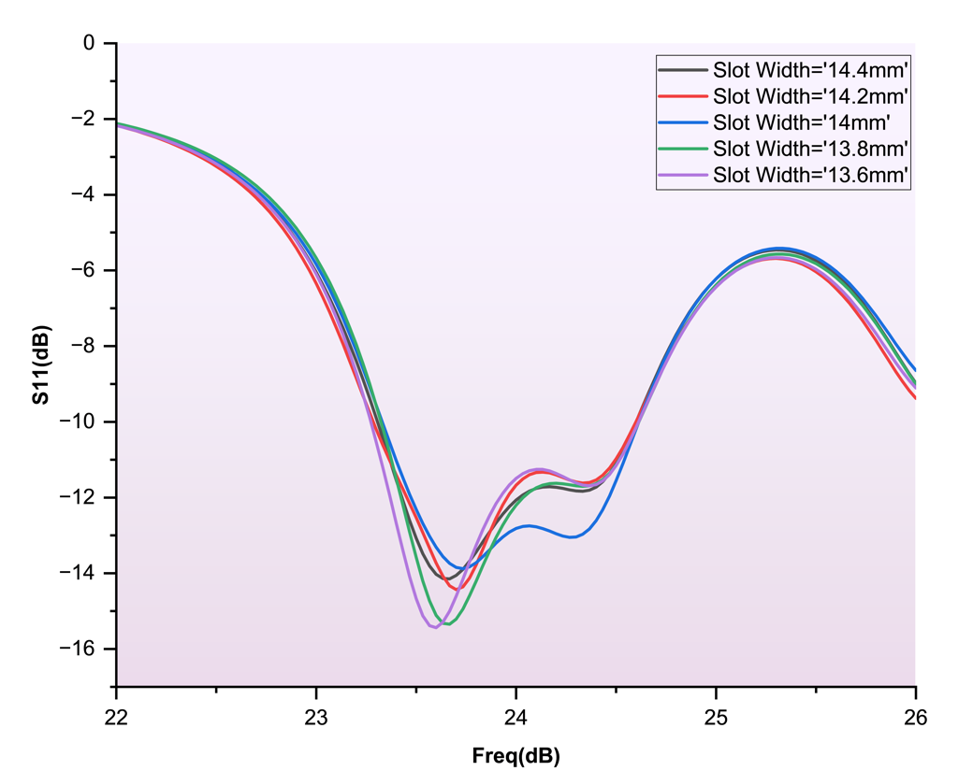

Figure 3.1.26: S11 vs Frequency Curves for Various Substrate Width

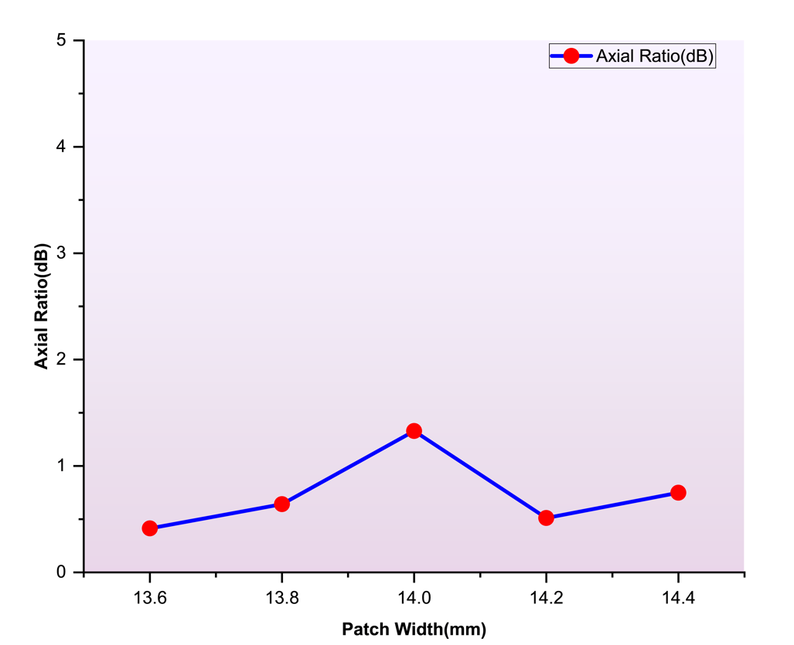

Figure 3.1.27: Axial Ratio vs Substrate Width Curve

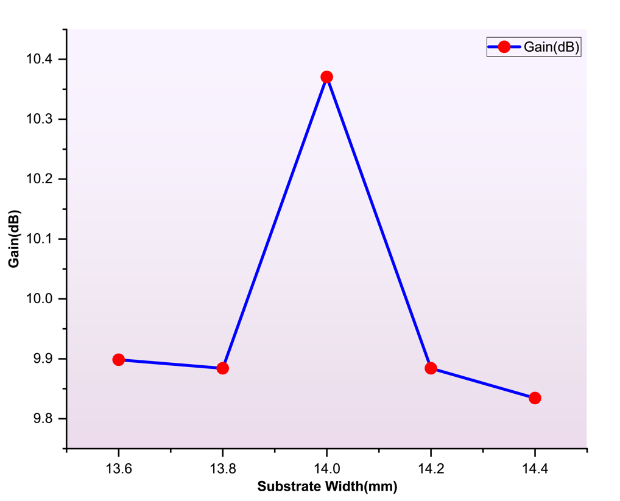

Figure 3.1.28: Gain vs Substrate Width Curve

Table 3.1.9: Gain and Axial Ratio Value for Various Substrate Width

|  |  |  |
| --- | --- | --- |
| **Slot Width(mm)** | **Gain(dB)** | **Axial Ratio(dB)** |
| 14.4 | 9.83 | 0.74 |
| 14.2 | 9.88 | 0.51 |
| 14.0 | 10.37 | 1.32 |
| 13.8 | 9.88 | 0.64 |
| 13.6 | 9.89 | 0.41 |

From Table 3.1.9, it can be observed that maximum gain was obtained at slot width of 14 mm, so this value was selected to move forward.

**3.1.7 Fine-Tuning**

After achieving a compact, circularly polarized antenna with optimized substrate and array geometry, a final fine-tuning step was conducted to ensure the antenna met precise performance criteria at 24 GHz. Specifically, the goal was to:

* Align the S11 resonance frequency exactly at 24 GHz
* Ensure the axial ratio remained below 3 dB at this frequency

**Parameters Adjusted**

The following dimensions were adjusted:

* Patch Dimension: Distance between centroid to vertex of triangular patch was reduced from 2.71 mm to 2.695 mm
* Slot width: Changed from 0.45 mm to 0.47 mm

After completing all design optimizations and fine-tuning steps, the final version of the triangular patch antenna array was established.

**Design Details**

Operating Frequency: 24 GHz

Polarization: Circular

Substrate Material: DiClad 880

Dielectric Constant (εr): 2.2

Substrate Thickness (h): 0.508 mm

Feeding Method: Coaxial probe feed

Ground Plane: Full ground plane, same as substrate size

Overall Array Dimensions: 16 mm × 14 mm

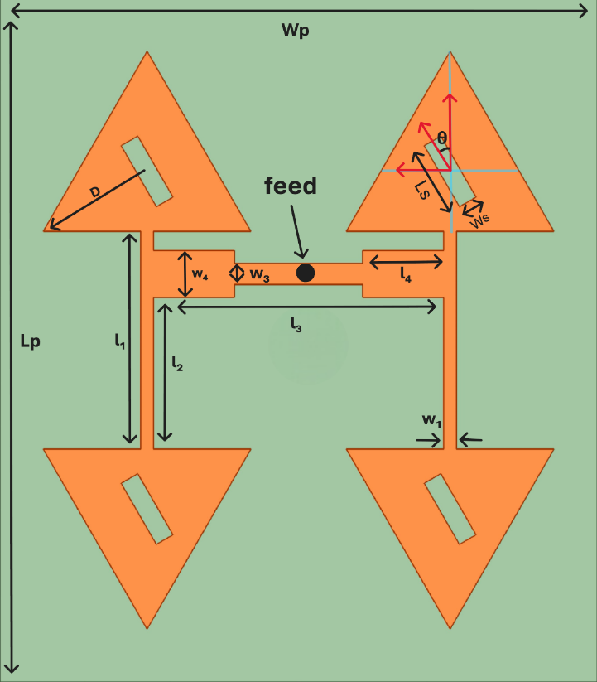

Figure 3.1.29: Final Antenna Array Geometry

Table 3.1.10: Final Antenna Array Geometry

|  |  |
| --- | --- |
| Substrate Length (Lp) | 16 mm |
| Substrate Width (Wp) | 14 mm |
| Slot Length (Ls) | 1.65 mm |
| Slot Width (Ws) | 0.47 mm |
| D | 2.695 mm |
| l1 | 5.205 mm |
| l2 | 3.515 mm |
| l3 | 6.8 mm |
| l4 | 1.9 mm |
| w1 | 0.3 mm |
| w3 | 0.5 mm |
| w4 | 1.1 mm |
| θ | 30 degree |

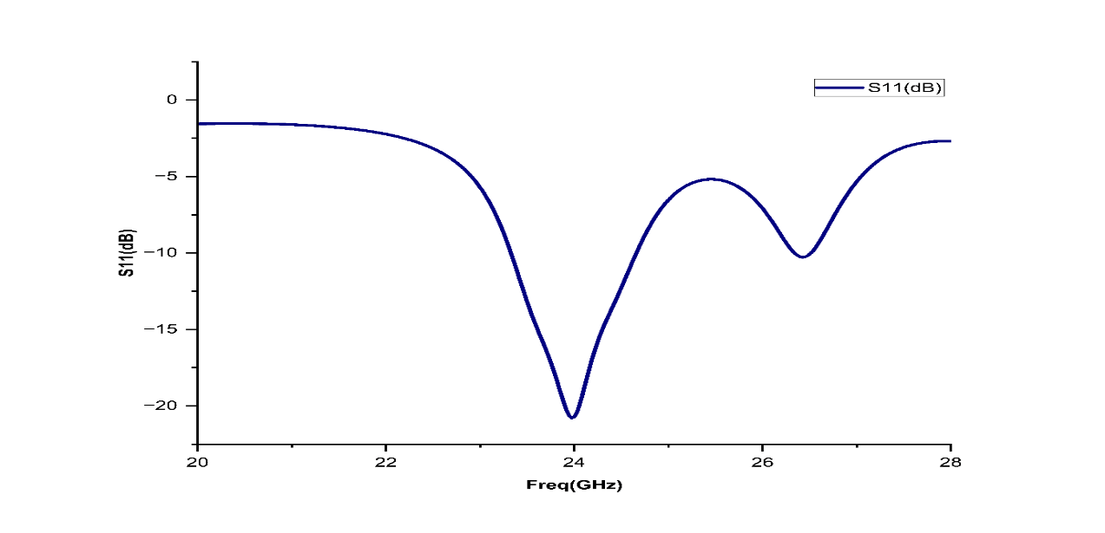

Figure 3.1.30: S11 vs Frequency Curve

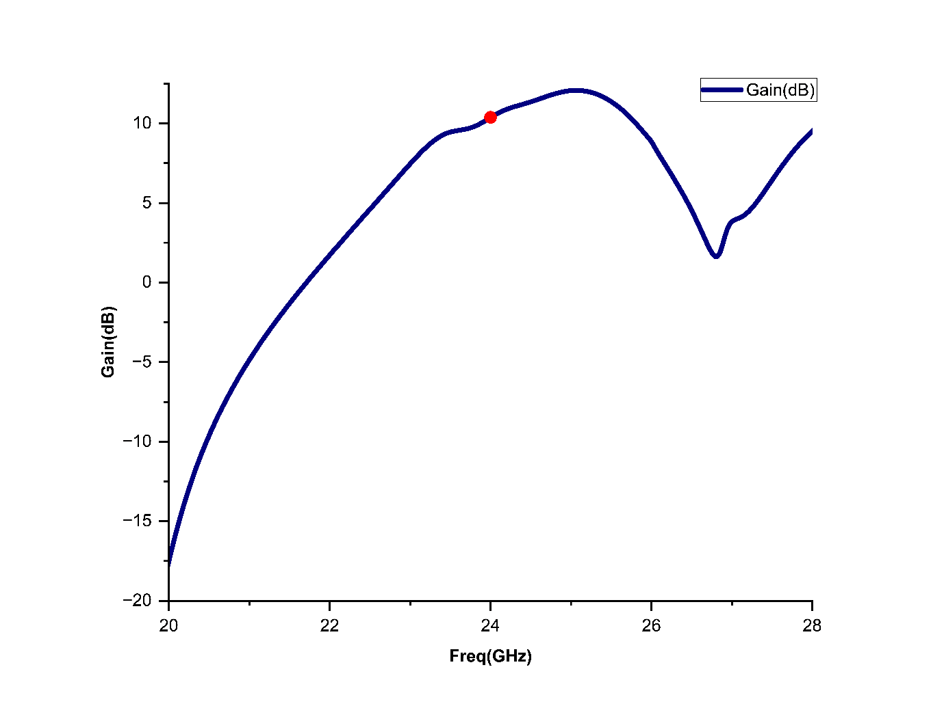

Figure 3.1.31: Gain vs Frequency Curve Showing Resonance at 24 GHz

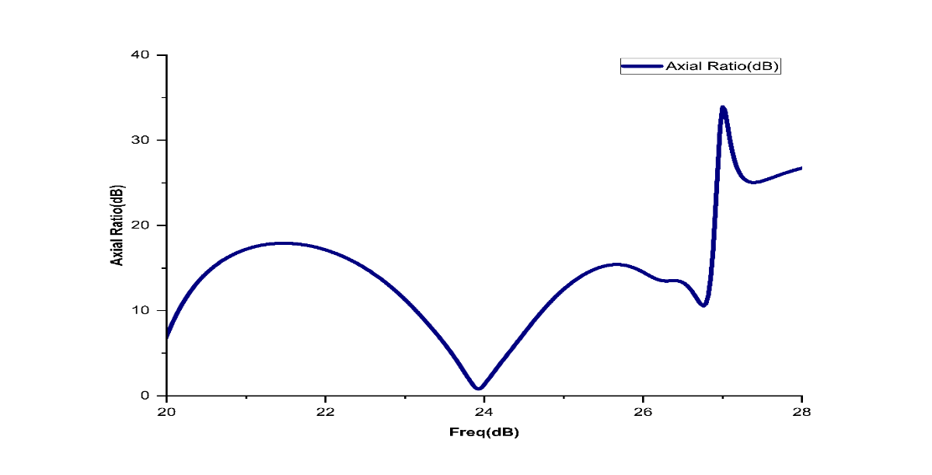

Figure 3.1.32: Axial Ratio vs Frequency Curve Showing Axial Ratio Less than 3 dB at 24 GHz

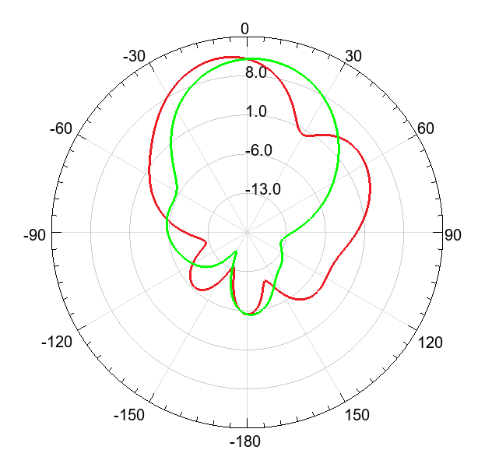

Figure 3.1.33: Radiation Pattern in both E(Red) and H(Green) Plane

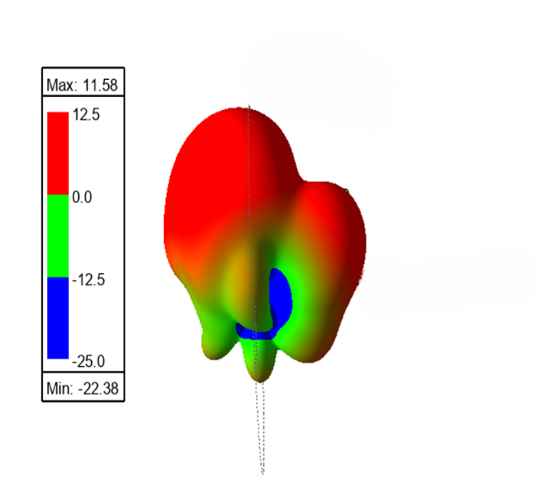

Figure 3.1.34: 3D Radiation Pattern

Table 3.1.11: Performance Parameters of The Designed Antenna Array

|  |  |
| --- | --- |
| **Resonance Frequency** | 24 GHz |
| **S11** | -20.2 dB |
| **Bandwidth** | 1.31 GHz |
| **Gain** | 10.43 dB |
| **Axial Ratio** | 1.32 dB |

## 3.2 RECTIFIER DESIGN

Rectification is the critical final stage of a rectenna system, responsible for converting the captured radio‑frequency (RF) signal into a usable direct‑current (DC) output. The performance of the rectifier—often measured by return loss (|S11|), power‑conversion efficiency (PCE), and delivered DC voltage—directly governs the overall energy‑harvesting efficiency of the rectenna. This subsection documents the systematic design, optimisation, and verification of a 24 GHz half‑wave series Schottky‑diode rectifier that interfaces seamlessly with the companion patch antenna presented in the previous chapter.

**Design Targets and Constraints**

The rectifier was specified to satisfy four quantitative targets derived from the system‑level requirements of the 24 GHz rectenna:

* Operating frequency – Centre: 24.00 GHz (ISM band); bandwidth ≥ 1 GHz for |S11|<–10 dB.
* Input impedance match – |S11| ≤ –18 dB at the design centre to minimise reflection at the antenna‑rectifier interface.
* Power‑conversion efficiency (PCE) – ≥ 65 % at 18 dBm RF input (anticipated peak field level).
* Peak DC output voltage – ≥ 2 V across an optimised load resistance (≈ 1 kΩ) under 18 dBm drive.

**Simulation Framework**

Table 1. Harmonic‑Balance & EM Simulation Parameters

|  |  |  |
| --- | --- | --- |
| **Parameter** | **Notes** | **Setting / Value** |
| Harmonic content (HB) | Captures diode non‑linearity without excessive runtime | Fundamental + harmonics 2–5 |
| Substrate | εr = 2.20; h = 0.508 mm | Rogers DiClad 880 |
| Conductor | Standard 1 oz copper cladding | Rolled copper, σ = 5.8 × 107 S m‑1 |
| EM mesh (Momentum) | Fine cells inside discontinuities and radial stubs | Base cell 20 µm; adaptive refinement to –40 dB |
| Temperature sweep | Validates stability of CJ and RS parameters | 20 °C – 60 °C |

3.2.1 Design Stages

The design advanced through multiple stages:

**3.2.1 Baseline (Stage 0)**

The starting point was the half‑wave series‑diode rectifier reported in a Wiley journal article. Implemented on **Rogers 5880** (εr = 2.2, h = 0.508 mm), the circuit comprised a 50 Ω feed line driving an MA4E1317 Schottky diode without any matching network. At **24 GHz** this reference achieved **< 10 % PCE** and exhibited a |S11| dip of roughly **-16 dB** centred near **25.4 GHz**—insufficient for the rectenna’s needs.

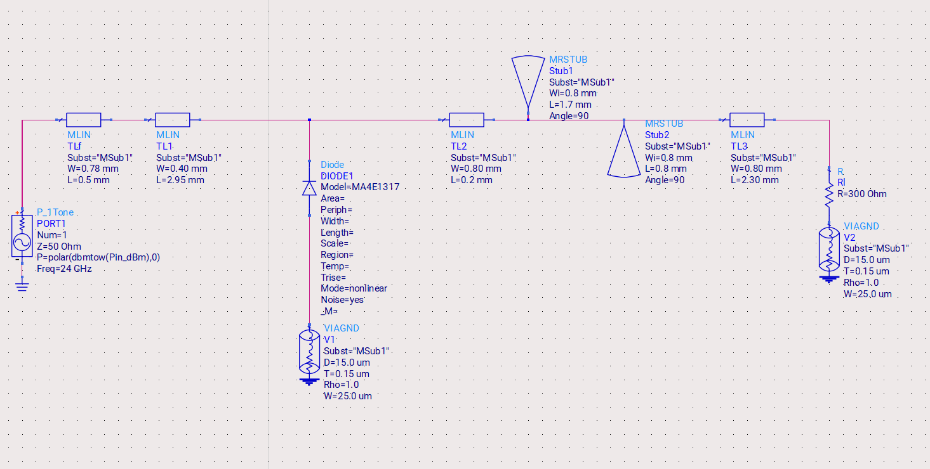

Figure 3.2.1: ADS Circuit Diagram for Baseline Rectifier Design based on [40]

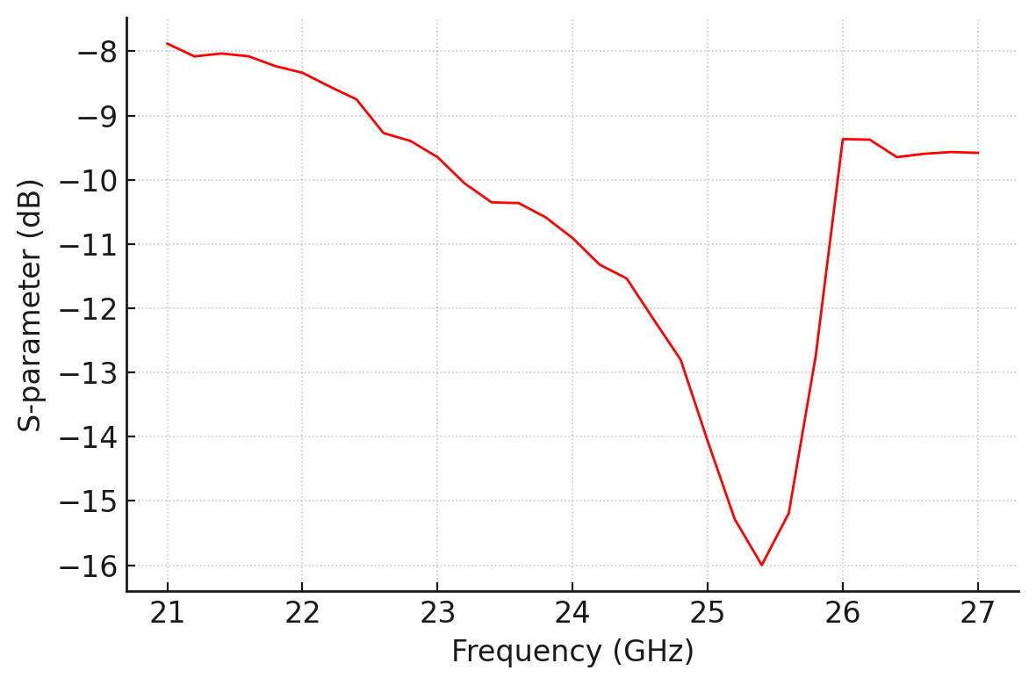

Figure 3.2.2: S11 vs Frequency for Baseline Rectifier Design based on [40]

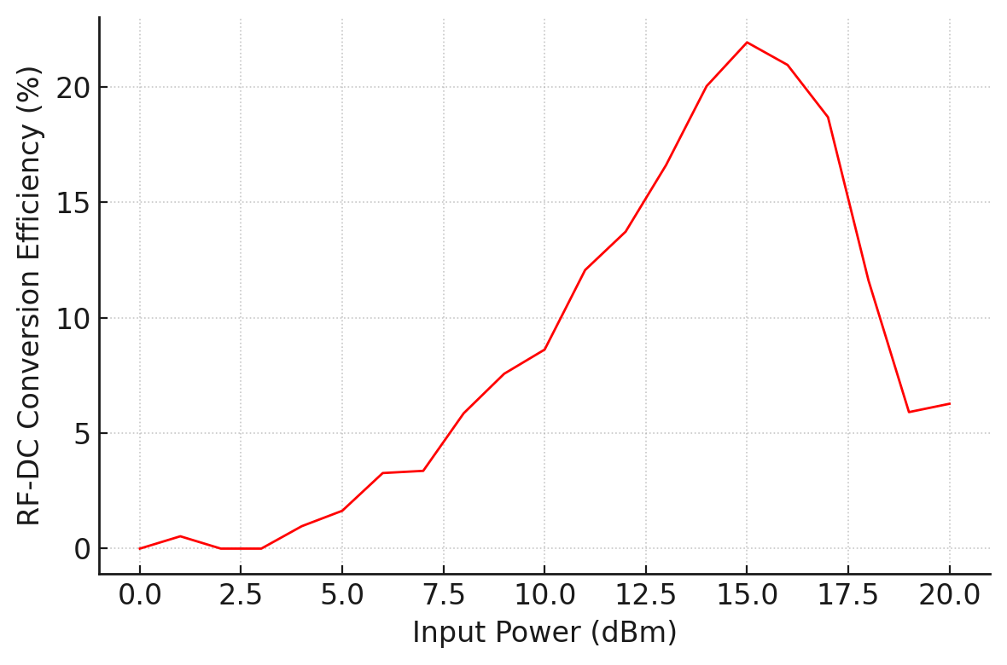

Figure 5.2.3: RF-DC Conversion Efficiency vs Input Power (dBm) for Baseline Rectifier Design based on [40]

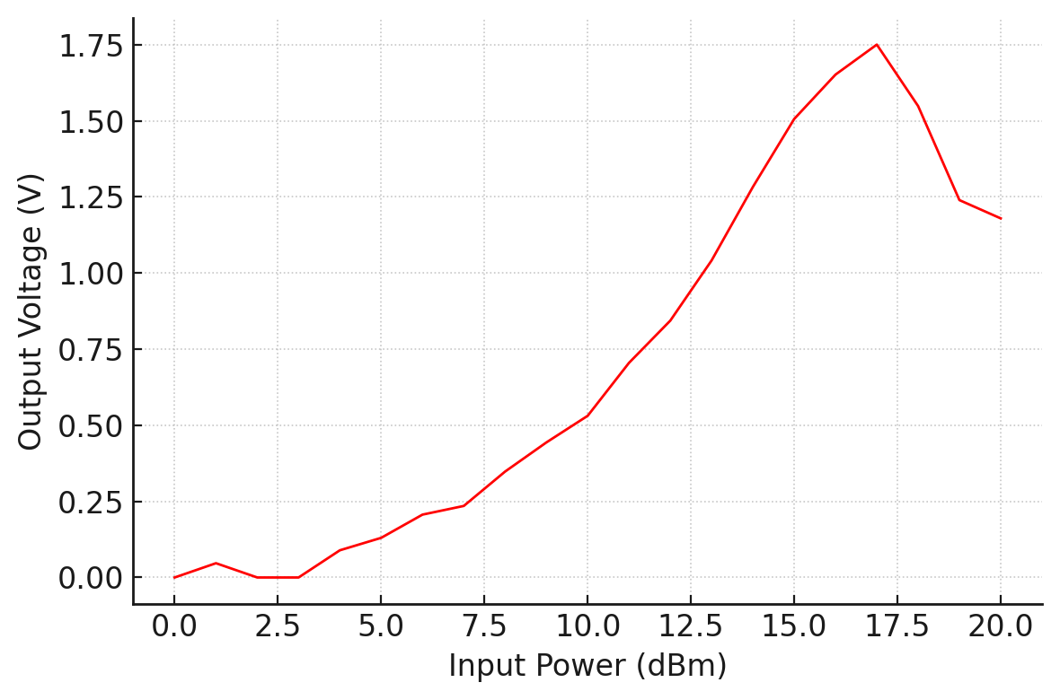

Figure 3.2.6: Output Voltage vs Input Power (dBm) for Baseline Rectifier Design based on [40]

**Parasitic‑Enhanced Design – Transmission‑Line Optimisation (Stage 1)**

To improve impedance match while retaining the RT/duroid 5880 substrate, we introduced parasitic capacitive pads at the diode junction and optimised adjacent microstrip segment lengths/widths. Using Harmonic‑Balance (HB) sweeps in Keysight ADS:

* The added pads cancelled residual diode inductance, and fine tuning of stub length to 1.64 mm relocated the |S11| minimum to 25.2 GHz with a depth of –12 dB.
* PCE improved to ≈ 30 %.

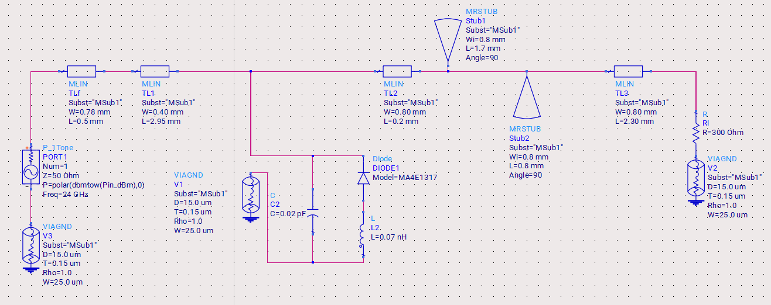

Figure 3.2.7: ADS Circuit Diagram for Rectifier Design with Parasitic Components

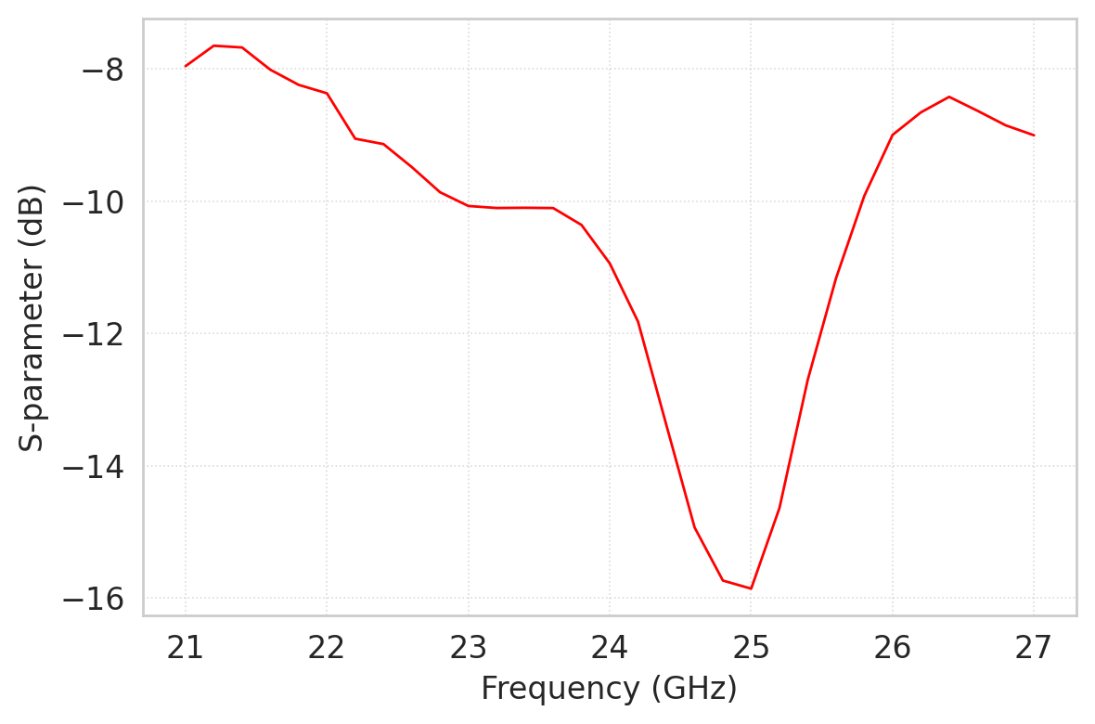

Figure 3.2.8: S11 vs Frequency for Rectifier Design with Parasitic Components

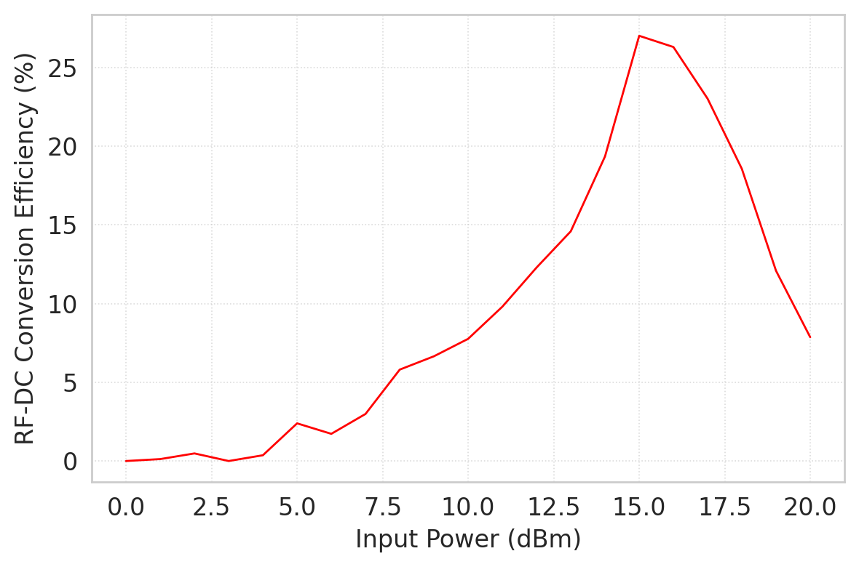

Figure 3.2.9: RF-DC Conversion Efficiency vs Input Power (dBm) for Rectifier Design with Parasitic Components

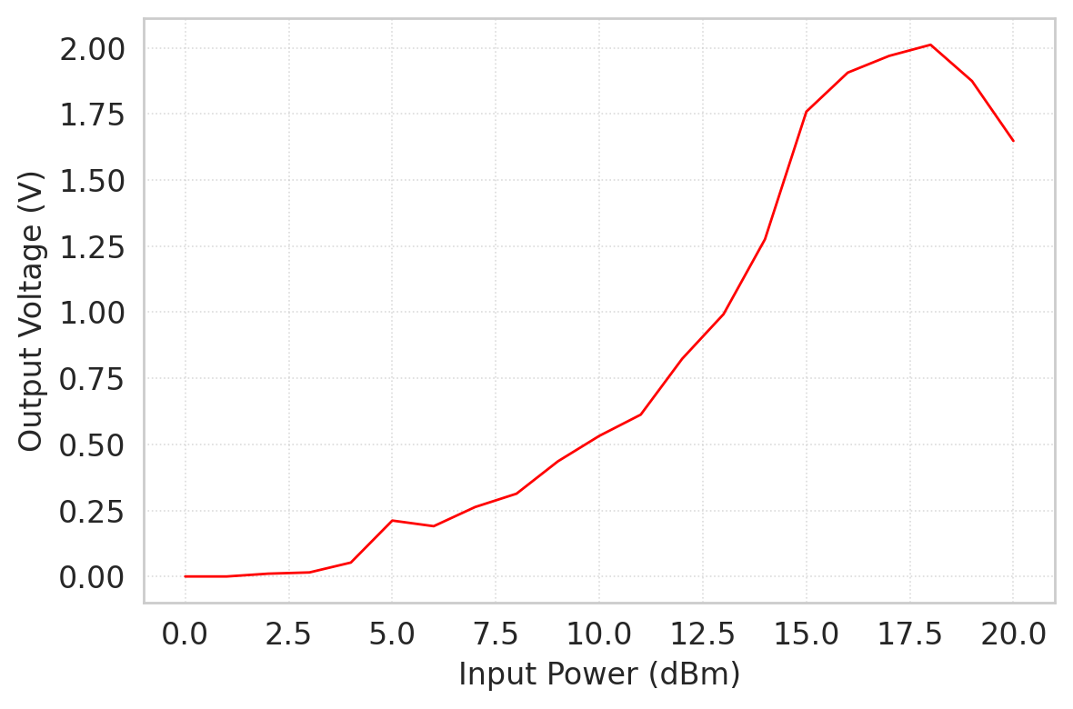

Figure 3.2.10: Output Voltage vs Input Power (dBm) for Rectifier Design with Parasitic Components

**Final Design – Substrate Migration to Rogers DiClad 880 (Stage 2)**

The decisive improvement came from transitioning the layout to Rogers DiClad 880 (εr = 2.2, loss tangent 0.0009 @ 10 GHz). Re‑optimising trace widths for the new dielectric constant and repeating HB/EM co‑simulation yielded:

* |S11|: –21 dB exactly at 24 GHz; < –10 dB across 23.3 – 25.5 GHz.
* PCEpeak: 67.26 % at 18 dBm input.
* VOUT, pk: 2.02 V across a 970 Ω load.

**Target Compliance**

|  |  |  |
| --- | --- | --- |
| **Metric** | **Achieved** | **Requirement** |
| |S11| @ 24 GHz | –18 dB | ≤ –16 dB |
| PCEpeak | 67.26 % | ≥ 65 % |
| VOUT, pk @ 18 dBm | 2.02 V | ≥ 2 V |

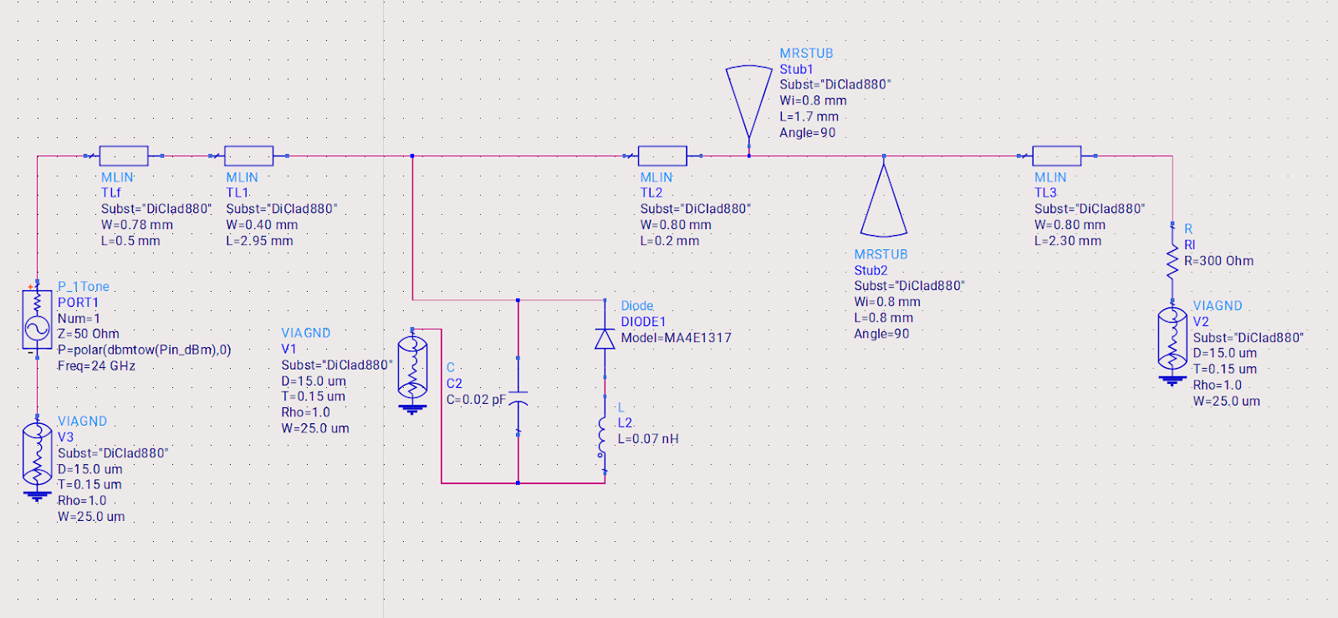

Figure 3.2.11: ADS Circuit Diagram for Rectifier Design with Parasitic Components and DiClad880 Substrate

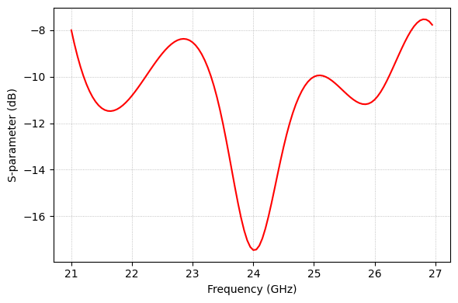

Figure 3.2.12: S11 vs Frequency for Rectifier Design with Parasitic Components and DiClad880 Substrate

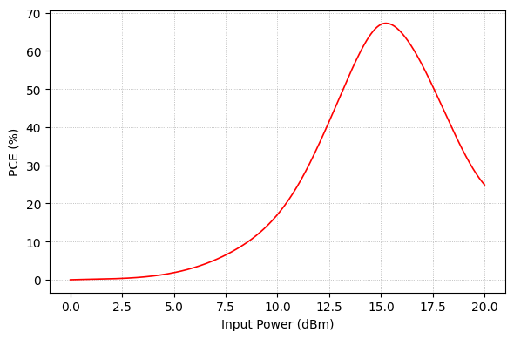

Figure 3.2.13: PCE vs Input Power (dBm) for Rectifier Design with Parasitic Components and DiClad880 Substrate

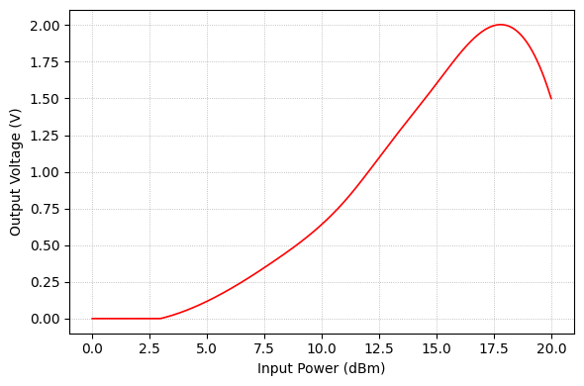

Figure 3.2.14: Output Voltage vs Input Power (dBm) for Rectifier Design with Parasitic Components and DiClad880 Substrate

**Final Rectifier Topology Overview**

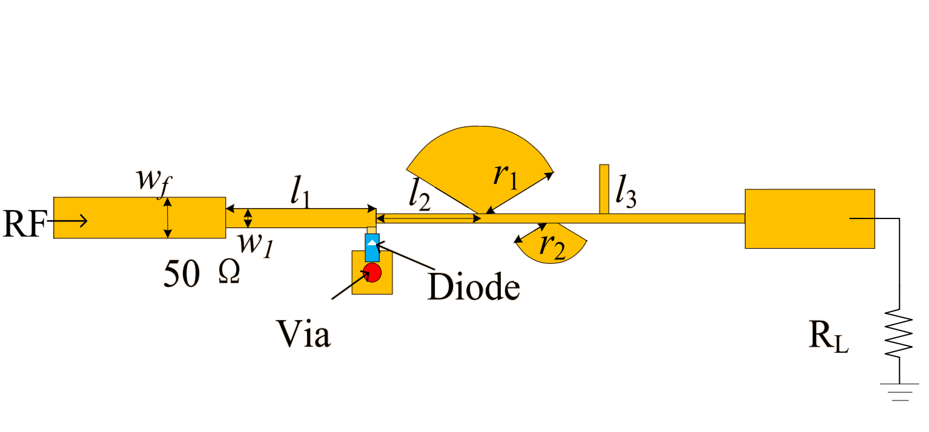

Figure 3.2.15: Annotated layout and equivalent ADS schematic of rectifier circuit

Beginning at the input, a 50 Ω microstrip feed-line 0.78 mm wide and 0.50 mm long launches the 24 GHz signal on Rogers DiClad 880 (εr= 2.20, h = 0.508 mm). This line tapers into a narrower 0.40 mm-wide, 2.95 mm-long section that initiates the impedance transformation toward the MA4E1317 Schottky diode. Immediately ahead of the diode sits a 0.80 mm-wide, 0.20 mm-long quarter-wave transformer, which brings the real part of the diode admittance close to 50 Ω at the design frequency.

The diode itself is mounted above a plated-through via for a low-inductance RF ground return, and is flanked by two radial stubs: a principal stub with an effective 1.7 mm radius and a helper stub of 0.8 mm radius. Together they present a broadband RF short at even-order harmonics while allowing DC to pass. A compact series 0.07 nH inductor and shunt 0.02 pF capacitor form a fine L-match that flattens the PCE peak and suppresses output ripple.

Rectified current then travels along a 0.80 mm-wide, 2.30 mm-long output line to a 300 Ω load, delivering ≈ 2 V DC when the rectifier is driven with an 18 dBm, 24 GHz input. This low-loss, harmonic-terminated layout—implemented entirely on DiClad 880—constitutes the final rectifier topology referenced in the subsequent design-stage discussion.

## 3.3 RECTENNA DESIGN

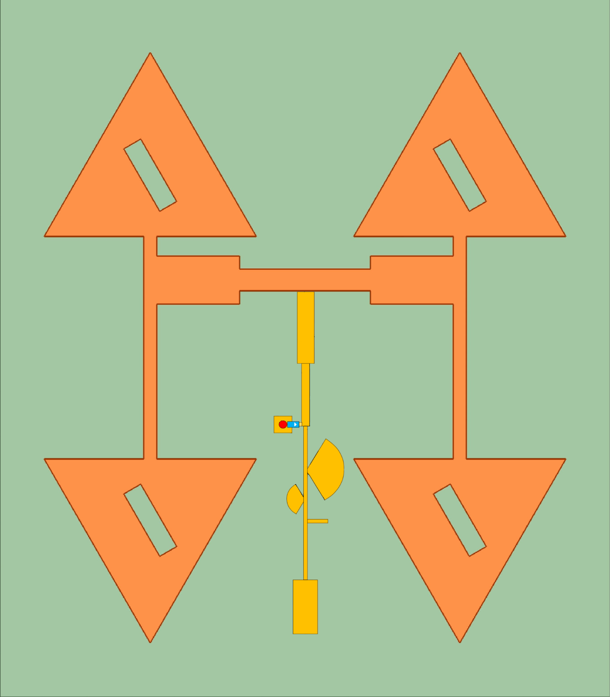

Figure 3.1.16:  Complete layout of the proposed integrated rectenna

In this project, we developed a high-performance 24 GHz rectenna specifically optimized for unmanned aerial vehicle (UAV) applications. The design incorporates a 2x2 microstrip patch antenna array to efficiently capture incident RF energy, coupled with a single-stage voltage doubler rectifier using Schottky diodes for optimal power conversion.

This rectenna system enables far-field wireless power transfer, which could significantly extend UAV operational endurance by harvesting ambient RF energy or dedicated power beaming signals. Future advancements may include multi-band operation for enhanced versatility, improved efficiency at lower power densities, and real-world deployment testing. By addressing critical challenges in UAV power sustainability, this work contributes to the development of next-generation autonomous systems capable of persistent aerial missions.

# 

# 4. RESULTS

The designed compact rectenna system for UAV applications demonstrated significant performance improvements through systematic optimization. The antenna array achieved a resonant frequency of 24 GHz with an S11 parameter of -17.5 dB, ensuring excellent impedance matching. The axial ratio of 1.32 dB confirmed effective circular polarization, while the gain reached 10.43 dB, suitable for efficient RF energy capture. The rectifier circuit exhibited a power conversion efficiency (PCE) of 67.26% at 18 dBm input power, delivering a DC output voltage of 2.02 V across a 970 Ω load. Simulations in ANSYS HFSS and Keysight ADS validated the design's robustness, with the rectenna's compact dimensions (16 mm × 14 mm) making it ideal for integration into lightweight UAV platforms.

# 5. CONCLUSION

This project designed and optimized a compact 24 GHz rectenna for UAVs, enabling efficient wireless power transmission to extend flight endurance. The antenna achieved a resonant frequency of 24 GHz with an S11 of -17.5 dB, ensuring strong impedance matching, while its circular polarization (axial ratio of 1.32 dB) and high gain (10.43 dB) enhanced energy capture. The rectifier demonstrated a high power conversion efficiency (PCE) of 67.26% at 18 dBm input, delivering 2.02 V DC output across a 970 Ω load. Simulations in ANSYS HFSS and Keysight ADS confirmed the design's robustness, with a compact size (16 mm × 14 mm) suitable for lightweight UAV integration. The rectenna's optimized performance addresses the need for sustainable power solutions in UAVs, supporting autonomous, long-duration missions. Future work could involve prototyping, real-world testing, and multi-band designs for broader applications. This research advances next-generation UAV power systems, combining high efficiency, compactness, and reliability for practical deployment. The results highlight the feasibility of rectennas in enhancing UAV operational capabilities through effective RF-to-DC energy conversion.

# 6. REFERENCES

1. Z.Q. Liu, Y.S. Zhang, Z. Qian, Z.P. Han, and W. Ni, "A novel broad beamwidth conformal antenna on unmanned aerial vehicle," Published in: IEEE Antennas and Wireless Propagation Letters (Volume: 11), 10 February 2012.
2. E.T. Rahardjo, F.Y. Zulkifli, Basari, D.Y. Herwanto, and J.T.S. Sumantyo, "Circularly polarized microstrip antenna array for UAV application," Proceedings of the International Symposium on Antennas & Propagation, 23-25 October 2013, Nanjing, China.
3. Karthikeya G, Thyagaraj Tanjavur "Microstrip dual band millimeter-wave antenna array for UAV applications” 21st International Conference on Microwave, Radar and Wireless Communications (MIKON), 09-11 May 2016, Krakow, Poland.
4. Dan Wu, Xi Chen, "Compact and Low Profile Omnidirectional Circularly Polarized Antenna with Four Coupling Arcs for UAV Applications," IEEE Antennas and Wireless Propagation Letters (Volume: 16),14 September 2017.
5. Tsai-Yun Chuang, Wen-Jiao Liao, Tzyh-Ghuang Ma, “Compact Directive Array Antenna Design for UAV Application”, International Symposium on Antennas and Propagation (ISAP), 30 October 2017 - 02 November 2017, Phuket, Thailand.
6. Alfian Maulana Yusuf, Heroe Wijanto "Dual C-X-Band E-Shaped Microstrip Antenna Array 1×8 for Synthetic Aperture Radar on UAV," IEEE International Conference on Signals and Systems (ICSigSys), 16-18 July 2019. Bandung, Indonesia.
7. Ivaylo Nachev, Peter Z, Petkov, “Radar Antenna Array Designing for Unmanned Aerial Vehicles (UAV)”, 55th International Scientific Conference on Information, Communication and Energy Systems and Technologies (ICEST), 10-12 September 2020, Serbia.
8. Elisa Giampietri1, Francesco Molesti, “A Compact Annular Ring microstrip antenna for Unmanned Aerial Vehicles (UAVs) applications”, 2021 IEEE International Symposium on Antennas and Propagation and USNC-URSI Radio Science Meeting (APS/URSI), 04-10 December 2021, Singapore.
9. Puza Mazumder and Mohammad Monirujjaman Khan, " Design and Analysis of a Multiple Input and Multiple Output Antenna for Unmanned Aerial Vehicle," 2021 12th International Conference on Computing Communication and Networking Technologies (ICCCNT), 06-08 July 2021, Kharagpur, India.
10. Aamir Shaikh, Manjusha Joshi. "Antennas in Airborne Applications." 2022 IEEE Bombay Section Signature Conference (IBSSC), 08-10 December 2022, Mumbai, India.
11. Ivaylo Nachev and Ilia Iliev, “Linearly polarized phased antenna array with an application for the automatic landing of unmanned flying vehicle”, 57th International Scientific Conference on Information, Communication and Energy Systems and Technologies (ICEST), 16-18 June 2022, Ohrid, North Macedonia.
12. Abderraoufe Zerrouk, Mohamed Lamine Tounsi, Mustapha C.E. Yagoub" A novel compact microstrip antenna for UAVs real-time applications using millimeter-waves band," IEEE Third International Conference on Signal, Control and Communication (SCC), 01-03 December 2023, Hammamet, Tunisia.
13. Nurkhairul Daniel Khairul Yushaini, Elfarizanis Baharudin, "Semi-circle ring antenna for 5G UAV application," IEEE International Symposium on Antennas and Propagation (ISAP), 30 October 2023 - 02 November 2023, Kuala Lumpur, Malaysia.
14. M.M. Hasan Mahfuz, Chan-Wang Park "Review of patch antennas used in drone applications," IEEE Access, Vol. 11, 08 June 2023.
15. C. Manikandan, R Maheswari. "Design of conformal antenna for UAVs in 5G midband for reliable coverage," International Conference on Electrical Electronics and Computing Technologies (ICEECT). 29-31 August 2024, Greater Noida, India.
16. Kapil Jain, Vivek Singh Kushwah & Rinkoo Bhatia, "A low-profile ultra-wideband hexagonal-patch antenna for UAV-based applications," International Journal of Electronics Letters 2024, Vol. 12, No. 4, 435–447, 2024. Published online: 02 May 2024.
17. Nobuyuki Takabayashi and Naoki Shinohara, "Large-Scale Sequentially-Fed Array Antenna Radiating Flat-Top Beam for Microwave Power Transmission to Drones" [IEEE Journal of Microwaves](https://ieeexplore.ieee.org/xpl/RecentIssue.jsp?punumber=9171629) ( Volume: 2, [Issue: 2](https://ieeexplore.ieee.org/xpl/tocresult.jsp?isnumber=9750182&punumber=9171629), April 2022). 06 April 2022.
18. Ihlou Salah, Tizyi Hafid "Design of a New Antenna Structure for an RF Energy Recovery System on a UAV,”7th Mediterranean Congress of Telecommunications (CMT), 24-25 October 2019, Fez, Morocco.
19. Rocco Citroni, Franco Di Paolo and Patrizia Livreri "A Novel Energy Harvester for Powering Small UAVs," Sensors 2019, 13 April 2019
20. Mengfan Wang, Jianing Chen, Xinwang Cui, and Long Li, "Design and Fabrication of 5.8 GHz RF Energy Harvesting Rectifier, [2019 Cross Strait Quad-Regional Radio Science and Wireless Technology Conference (CSQRWC)](https://ieeexplore.ieee.org/xpl/conhome/8785420/proceeding),Taiyuan, 18-21 July 2019.
21. Karush Suri, Mohit Mohta, "Design of a Dual Band Rectifier Circuit for Drone Powering Applications" [2017 8th International Conference on Computing, Communication and Networking Technologies (ICCCNT)](https://ieeexplore.ieee.org/xpl/conhome/8123903/proceeding), IIT Delhi, Delhi, India, 2017,July 3-5, 2017.
22. Yu Yang Xiao, Zhi-Xia Du, "High-Efficiency Rectifier with Wide Input Power Range Based on Power Recycling," [IEEE Transactions on Circuits and Systems II: Express Briefs](https://ieeexplore.ieee.org/xpl/RecentIssue.jsp?punumber=8920) ( Volume: 65, [Issue: 6](https://ieeexplore.ieee.org/xpl/tocresult.jsp?isnumber=8365894&punumber=8920), June 2018), 17 January 2018.
23. Y Satyavani, "Design and Development of Wireless Power Transfer System for UAV," International Conf. on Sustainable Energy and Future Electric Transportation, January 2021, GRIET, Hyderabad, India. [International Conference on Sustainable Energy and Future Electric Transportation (SEFET)](https://ieeexplore.ieee.org/xpl/conhome/9375499/proceeding). Conference Hyderabad,India, 21-23 January 2021.
24. Xirui Zhu, Ke Jin "Long-Range Wireless Microwave Power Transmission: A Review of Recent Progress," [IEEE Journal of Emerging and Selected Topics in Power Electronics](https://ieeexplore.ieee.org/xpl/RecentIssue.jsp?punumber=6245517) ( Volume: 9, [Issue: 4](https://ieeexplore.ieee.org/xpl/tocresult.jsp?isnumber=9502054&punumber=6245517), August 2021), 16 November 2020.
25. Erdem Asa, Lincoln Xue, Mostak Mohammad, Veda P., "A 1MHz Oak Ridge AC / DC Converter for UAV Contactless Charger Implementation,  [IEEE Applied Power Electronics Conference and Exposition (APEC)](https://ieeexplore.ieee.org/xpl/conhome/9773364/proceeding), Houston, TX, USA, 20-24 March 2022.
26. Ping Lu, Yuke Xia, Enpu Lei "Airborne Flexible Rectifying Metasurface System for Wirelessly Powered Unmanned Aerial Vehicles (UAVs)," [IEEE Transactions on Antennas and Propagation](https://ieeexplore.ieee.org/xpl/RecentIssue.jsp?punumber=8) ( Volume: 72, [Issue: 10](https://ieeexplore.ieee.org/xpl/tocresult.jsp?isnumber=10706991&punumber=8), October 2024), 12 August 2024.
27. David C. Jenn, Ric Romero "An Improved Rectenna for Wireless Power Transmission for UAV," 2011.
28. Ronny Hafeza, Hasan Esfeer, "Wireless Far-Field Charging of a Micro-UAV," 2015 IEEE Wireless Power Transfer Conference (WPTC), 13-15 May 2015, Boulder, CO, USA.
29. Antonio Carvalho, Nuno Carvalho " 5.8 GHz Microstrip Antennas and Array for Microwave Power Transfer", 2015 9th European Conf. on Ant. and Prop. (EuCAP). 13-17 April 2015, Lisbon, Portugal.
30. Kang-Rong Li, Kye-Yak See, "Design of 2.45 GHz Microwave Wireless Power Transfer System for Battery Charging Applications, " Progress in Electromagnetics Research Symposium - Fall (PIERS - FALL), 19-22 November 2017, Singapore.
31. Yudai Hashimoto, Qiaowei Yuan, Takumi Aoki, "Drone Driven by Microwave," 2018 Asia-Pacific Microwave Conference (APMC), 06-09 November 2018, Kyoto, Japan.
32. Satoru Suganuma, Duc Hung Nguyen, "Autopilot Drone with Rectenna for 28GHz Microwave Irradiation- Measurement”, Asia-Pacific Microwave Conference (APMC), 06-09 November 2018, Kyoto, Japan.
33. Vandana Das, Sabarish Narayanan "Low Frequency Rectenna for Wireless Charging of Unmanned Aerial Vehicles," 4th International Conference on Electronics, Communication and Aerospace Technology (ICECA), 05-07 November 2020, Coimbatore, India.
34. Nobuyuki Takabayashi, Tomohiko Mitani, "Rectification Improvement with Flat-Topped Beams on 2.45-GHz Rectenna Arrays," IEEE Trans on Microwave Theory and Techniques, Vol 68, Issue 3, March 2020.
35. Naoki Hasegawn, Yuta Nakamoto, "Lightweight Rectenna array for Demonstration of Microwave Power Transfer to Flying -Objects," IEEE Asia-Pacific Microwave Conference (APMC). 28 November 2021 - 01 December 2021, Brisbane, Australia.
36. Ryoma Moro, Naoki Keicho, " 28 GHz Microwave Power Beaming to a Free-Flight Drone," IEEE Wireless Power Transfer Conference (WPTC),01-04 June 2021, San Diego, CA, USA.
37. David Chatzichristodoulou1, Abdul Quddious, Loukia Vassiliou, "Wireless Charging of Ground-based Sensors from a UAV-carried Transmitter," IEEE Int. Symposium on Antennas and Propagation and USNC-URSI Radio Science Meeting (APS/URSI), 04-10 Dec. 2021, Singapore, Singapore.
38. Win Adiyansyah Indra, Safarudin Gazali Herawan, “Development of A Guided Drone Powered by Radio Frequency Energy Harvesting”, IEEE International Conference in Power Engineering Application (ICPEA), 08-09 March 2021, Malaysia.
39. Maho Matsukura, Ryoma Moro. "Wireless Charging for Hovering-Drone via Millimeter Wave," Wireless Power Week (WPW), 05-08 July 2022, Bordeaux, France.
40. P. P. Shome, D. Sarkar, T. Khan, N. Shinohara and Y. M. M. Antar, "From Waves to Watts: Advancements in rectenna arrays for radio-frequency energy harvesting and wireless power transfer," in IEEE Antennas and Propagation Magazine, Issue 01 January, 2025.
41. Huang, W., Du, J., Yang, X., Che, W., & Gao, S. (2023). A novel 24 ghz circularly polarised metasurface rectenna. IET Microwaves, Antennas &Amp; Propagation, 17(6), 419-426, Issue 01 february, 2023.